Effect of inhomogeneous surface albedo
on diffuse UV sky radiance at a high altitude site

Martin Huber, Mario Blumthaler, Josef Schreder, Barbara Schallhart
Institute of Medical Physics, University of Innsbruck, Austria

Jaqueline Lenoble
Laboratoire d’Optique Atmosphérique, Université des Sciences et Technologies de Lille, France

Corresponding author:

Mario Blumthaler
Institute of Medical Physics
Muellerstrasse 44
A-6020 Innsbruck
Austria

Tel xx43-512-507-3556, Fax xx43-512-507-2860
Email: mario.blumthaler@uibk.ac.at
Abstract
Situated at the very edge of the Aletsch Glacier and thus at the boundary between snow-covered and snow-free terrain, the High Alpine Research Station Jungfraujoch (Switzerland, 3576 m a.s.l.) represents an ideal site for experimental quantification of surface albedo effects on solar UV radiation. Monochromatic measurements of directional radiance distribution in the sky, performed with a 1° aperture lens optics at 310 nm and 350 nm under cloudless sky conditions, are compared with discrete ordinate model calculations of corresponding data over homogenously snow-covered terrain, taking into account polarization effects for an aerosol free atmosphere. The model agrees within ±5% with radiance measurements at the forward scattering direction of the principal plane towards Southeast, where snow covered terrain dominates. Towards Northwest, the effect of snow free terrain causes a significant reduction of UV sky radiance at the backward scattering direction of the principal plane relative to the modelled situation with homogenous snow cover. Depending on the actual solar zenith angle, this reduction amounts between 20% and 40%.

Introduction
As a consequence of increased public and scientific interest in biologically relevant solar UV radiation reaching the earth’s surface, the effects of atmospheric and environmental parameters on UV transmittivity of the earth’s atmosphere have shifted into the scope of recent scientific efforts. In particular, the enhancement of solar UV radiation by increased ground albedo has been quantified by field measurements and by model calculations. As an example, McKenzie et al. (1998) report an increase of global UV irradiance under cloudless sky conditions at Lauder (New Zealand) due to snow cover by 22% in the UVA region and by 28% in the UVB region. Smolskaia et al. (1999) mention possible impacts of enhanced solar UV irradiance on marine biota around ice edges in the Antarctic sea and describe variations in erythemally weighted global UV irradiance along 5 km transects perpendicular to an ice/water boundary. The maximum enhancement of global UV irradiance by a highly reflective snow surface is quantified to 10 % in comparison to measurements over open water. Calculations from three-dimensional radiative transfer models predict significantly higher albedo effects of up to 35% (Degünther et al., 1998; Kyilling et al., 2000; Mayer and Degünther, 2000), depending on the actual pattern of snow distribution.
Up to now, experimental investigation of ground albedo effects on solar UV radiation has been restricted to global UV irradiance, which is given by the integral of UV radiance over the upper hemisphere, weighted with the cosine of zenith distance. This integral value describes the enhancement of solar UV radiation by ground reflectivity merely as a coarse average, especially under conditions with inhomogeneous ground albedo, when effects of ground reflectivity on diffuse sky radiance can be expected to depend on the direction of observation. In order to characterize these effects in greater detail, the present paper compares diffuse sky radiance data from 45 directions of observation, taken at the High Alpine Research Station Jungfraujoch (Switzerland, 3576 m a.s.l.) at inhomogeneously snow covered terrain, with calculations of corresponding data from a one-dimensional radiative transfer model assuming homogenous snow cover conditions. The results provide a reference for the validation of highly sophisticated three-dimensional radiative transfer models, which are capable of the model description of inhomogeneous surface albedo. Although measurement data of UV sky radiance distribution are already available (Ireland and Sacher, 1995; Blumthaler et al., 1996), they have not yet been compared with the results of one-dimensional or three-dimensional radiative transfer models. Moreover, detailed characterisation of diffuse sky radiance is a prerequisite for effect studies regarding biological effects of solar UV radiation which are often poorly described by global solar UV irradiance, for example the exposure of the human eye.

Materials and Methods

a. Radiance measurements
The Jungfraujoch High Alpine Research Station (Switzerland, 3576 m a.s.l.) is located at a ridge between the summits of Jungfrau (4158 m a.s.l.) and Mönch (4107 m a.s.l.). Even in summer, the surrounding of the Research Station towards Southeast is largely dominated by the highly reflective snow covered faces of Mönch and Jungfrau and by the Aletsch Glacier. In contrast, the area towards Northwest is dominated by low altitude terrain with vegetation and low surface albedo, merely the comparatively small Eiger Glacier represents a region with high surface albedo (Fig. 1, left).
At the Research Station’s observation platform, a suntracker, equipped with a 1° aperture telescope, was mounted on top of a pole, whereby obstruction by nearby objects, was largely prevented. The instrument’s view of the upper hemisphere was slightly restricted towards West by the dome of the Research Station’s astronomical telescope, and towards Northeast and Southwest by the summits of Jungfrau and Mönch. However, in the directions of the radiance measurements, which was Northwest and Southeast, the instrument had clear view of the sky down to an elevation angle of 0° (Fig. 1, right). A quartz fibre connected the telescope to a Bentham DTM300 high resolution double monochromator, which was thermally stabilised at 28.5 °C. The DTM300’s input and exit slits were adjusted to 0.74 mm, corresponding to a triangular slit function with 0.52 nm full width at half maximum (FWHM). Further details of the measurement setup are described by Blumthaler et al. (1996). At different solar zenith angles under clear sky conditions, diffuse sky radiance was determined with the monochromator’s wavelength selection successively set to 310 nm and 350 nm. At each wavelength, radiance was measured from 40 to 45 directions of the principal plane, which is defined by the vertical plane that includes the direction from the observer towards the sun. In addition, radiance was measured along the solar almucantar, which comprises all directions with the same zenith distance as the sun. A full set of radiance measurements took about 3 minutes for each wavelength setting. Aerosol optical depth between 300 nm and 400 nm was determined from direct solar irradiance measured with the same telescope. The DTM300 was calibrated relative to the extraterrestrial solar spectrum on May 22 and 23, 2000 by means of the Langley plot method (Gröbner and Kerr, 2001), which revealed a statistical uncertainty of about ±2% (2σ range) for individual spectral measurements of direct solar irradiance. Thus, the maximum resulting uncertainty in UV aerosol optical depth can be quantified to ±0.02 (2σ range) at small solar zenith angles.

b. Radiance calculations
In order to quantify the effect of low surface albedo, radiance measurements from the Jungfraujoch towards Northwest, where snow free terrain dominates, were compared with modelled radiance data, calculated for a hypothetical situation with homogenously snow covered terrain. The model parameters for this situation were determined from radiance measurements towards Southeast, where snow covered terrain dominates. The model uses a “pseudospherical” geometry. As a first step, direct solar irradiance is calculated as a function of altitude, whereby the atmosphere’s spherical geometry is taken into account. As a second step, the spatial and directional radiance distribution resulting from multiple scattering of direct solar irradiance is determined from a radiative transfer integral differential equation which only accounts for vertical variations of the atmosphere’s composition (Chandrasekhar, 1960). In horizontal directions, the atmosphere is considered infinite and homogenous. This simplified model assumption results in unreliable modelling of radiance data at observation zenith angles of more than about 85°, where the difference between the assumed plane parallel geometry and the actual spherical geometry of the atmosphere becomes significant.
In detail, ground reflection and atmospheric absorption and scattering are described by means of 60 plane parallel horizontal layers. Within each layer, homogenous conditions are assumed. The radiative transfer integral differential equation is solved by a 16 stream discrete ordinate method (DISORT; Stamnes et al., 1988). The model uses Rayleigh scattering cross sections given by Bodhaine et al. (1999), ozone absorption cross sections from Paur and Bass (1985) and a vertical ozone distribution representative for average conditions at mid latitudes(Iqbal, 1983). Lambertian ground reflectance is assumed and the phase function P(θ) of aerosol scattering is described by (Henyey and Greenstein, 1941)
$$P(θ)=\frac{1−g^{2}}{{\left(1+g^{2}−2 g \text{cos}θ\right)}^{ 1\text{.}5}}$$
thus leaving the asymmetry factor g as the only open parameter.
As DISORT does not account for polarization effects, a correction function (Fig. 2) is calculated from a successive order of scattering code (SOS, available to J. Lenoble), which has been successfully compared with several codes including DISORT (Van Weele et al., 2000) in the scalar case. In order to account for polarization, the scalar equation of transfer is replaced by a vector equation on 3 Stokes parameters (neglecting ellipticity). The SOS code solves this vector equation by following iteratively the photons scattered one or several times. The SOS code cannot account for atmospheric aerosols and the polarisation correction function is thus determined for a pure Rayleigh atmosphere. Consequently, the application of the polarisation correction function to solar radiance data calculated by the DISORT model, which just accounts for non-polarising effects of atmospheric aerosol, neglects the polarisation effects of atmospheric aerosols. However, at the Jungfraujoch, which is characterized by extremely low atmospheric aerosol content, this just causes minor second order errors.

Results

a. Optimization of model parameters
By means of a least square algorithm, optimum model description of direct solar irradiance (Huber et al., 1995), measured on May 24, 2000 under cloudless sky conditions, revealed actual values of 326 ± 6 DU (2σ range) for total atmospheric ozone amount and of 0.04 ± 0.02 (2σ range) for aerosol optical depth at 350 nm.
Although diffuse sky radiance from a certain direction is formed by multiple scattering processes in the atmosphere, the last of these scattering processes necessarily takes place along the line of sight in the direction of observation. Thus, diffuse sky radiance from directions towards Southeast at observation zenith angles greater than 30° is ultimately caused by scattering processes which take place at a location clearly above snow covered terrain. Assuming that radiance measurements in the forward scattering direction of the principal plane (observation azimuth angle = solar azimuth angle) are hardly influenced by the snow-free terrain north of the observation site when the sun is located in the Southeast or in the South, these data were used to determine a model description of diffuse sky radiance at 350 nm above snow covered terrain. In detail, the model value for aerosol optical depth was varied between 0.02 and 0.06 and the model value for aerosol single scattering albedo was varied between 0.85 and 0.99. For extreme combinations of these parameters, surface albedo and the asymmetry factor g describing the aerosol phase function were determined to minimise the squares of the relative deviations between modelled radiance I_{calc} and measured radiance I_{meas}, normalised by their respective means ${\overline{I}}_{\text{meas}}$and ${\overline{I}}_{\text{calc}}$:
$\begin{aligned}\sum_{\text{30}°≤J_{i}≤\text{80}°}{}j_{i}=j_{\text{SUN}}\end{aligned}\left|J_{i}−J_{\text{SUN}}\right|³7°$ (1)
In this expression, ϕ_{i} and ϑ_{i} denote observation azimuth and zenith angles for the i-th radiance measurement. Radiance measurements taken from directions with less than 7° angular distance from the sun might be unreliable due to straylight in the instrument’s telescope, caused by direct solar irradiance, and are therefore neglected. Furthermore, calculated radiance data for observation zenith angles of more than 80° are not accounted for as the DISORT model becomes unreliable close to the horizon. Normalisation of measured and modelled radiance data becomes necessary as even a small error in the DTM300’s absolute calibration would result in a systematic bias of the optimisation process. An attempt to determine all four model input parameters (surface albedo, aerosol optical depth, aerosol single scattering albedo and asymmetry factor g) by optimisation of expression (1) resulted in a numerically ill-conditioned problem, indicating that the effects of these parameters on diffuse sky radiance cannot be distinguished within the uncertainties of the measurement data. In particular, the effects of increasing aerosol single scattering albedo and increasing aerosol optical depth are nearly identical at low atmospheric aerosol loads present at the Jungfraujoch.
However, restricting aerosol optical depth and aerosol single scattering albedo to reasonable limits and performing the summation in expression (1) simultaneously for 350 nm radiance data measured at 63° and at 45° solar zenith angle, a Levenberg-Marquardt optimisation algorithm (Marquardt, 1963) yielded numerically stable results (Table 2). Depending on the predefined values for aerosol optical depth and aerosol single scattering albedo, the optimised values for the asymmetry factor g amount between 0.612 and 0.764. The optimised values of surface albedo amount between 0.789 and 0.839, which is consistent with a generally accepted albedo value for snow covered terrain of about 0.8 (Feister and Grewe, 1995). For comparison, a surface albedo of 0.65±0.1 (2σ range) was determined from simultaneously measured spectra of global solar irradiance, following the "spectral slope method" described by Weihs et al. (2001). As global irradiance is determined by sky radiance from all directions, this value represents an average surface albedo for the surrounding of the measurement site.
Although the optimisation process results in reasonable values of surface albedo and aerosol asymmetry factor, the determination of these parameters is subject to comparatively large uncertainties. Even when modelling errors are neglected, the uncertainty of ±0.02 (2σ range) in aerosol optical depth at 350 nm, which has to be predefined for the optimisation process, results in an uncertainty of about ±0.06 (2σ range) for the optimised value of the aerosol asymmetry factor g (Table 2), which is further enhanced by uncertainties in the predefined value for aerosol single scattering albedo. Although the optimised value for ground albedo is less sensitive to variations of the predefined parameters, the low sensitivity of modelled normalised radiance data to ground albedo results in a high level of uncertainty. Over the range of zenith angles used for minimisation of expression (1), a variation of the model value for ground albedo between 0.7 and 0.9 results in a variation of calculated normalised radiance by less than 5% (Fig. 3). As the model does not account for the actual mountainous topography of the Jungfraujoch’s surrounding, it cannot realistically be expected to describe the actual radiance situation on a level of better than 5%. As a consequence, in its effect on normalised radiance a value of 0.7 for surface albedo cannot be distinguished from a value of 0.9 within the range of modelling uncertainties. Despite these uncertainties, the values for ground albedo and aerosol asymmetry factor g determined by minimisation of expression (1) allow a model description of homogeneously snow covered terrain which is consistent with the corresponding measurement data of diffuse sky radiance in the forward scattering direction of the principal plane (Fig. 4).

b. Effect of inhomogeneous albedo on radiance
Applying the optimised sets of input parameters to model calculations of diffuse sky radiance also for backward scattering directions of the principal plane and along the solar almucantar, a hypothetical situation with homogenously snow covered terrain can be simulated. As the actual values of aerosol optical depth and aerosol single scattering albedo are only known within certain limits, these modelled radiance data have to be specified within an uncertainty range of up to ± 6%. Actual radiance measurements above partly snow free terrain in the Northwest of the observation site show a general decrease relative to the model data and a shift of the radiance minimum in the backward scattering direction of the principal plane (azimuth angle equals 180° relative to solar azimuth). This general feature, observed at all solar zenith angles (Fig. 4), results from gradually increasing influence of low albedo towards higher observation zenith angles the backward scattering direction.
Fig. 5 shows the effect of inhomogeneous surface albedo under the local situation given at the Jungfraujoch Research Station, quantified by the deviation of measured radiance data from model calculations for a hypothetical situation with homogenously snow covered terrain. Within the given uncertainties of ± 6% for the model data, maximum reduction of diffuse sky radiance in the backward direction of the principal plane amounts to about 20% at 63° solar zenith angle, to about 40% at 45° solar zenith angle and to about 30% at 30° solar zenith angle. Along the solar almucantar, maximum reduction of diffuse sky radiance by low surface albedo generally occurs in the direction opposite to the sun. No significant differences between albedo effects at 350 nm and at 310 nm can be observed.
The observed reduction of diffuse sky radiance from the backward scattering direction of the principal plane can be modelled by a hypothetical situation with homogenous surface albedo of 0.4 (Fig. 4). As the surface towards Northwest is in general 1500 to 2500 m below the altitude of Jungfraujoch, backscattering by the atmospheric layer below the measurement site also has to be taken into account. This reduces the surface albedo value mentioned above to a value of about 0.35, which is still an unrealistically high value for snowfree terrain. It can hardly be explained by the reflective surface of the comparatively small Eiger Glacier located in the Northwest of the observation site. Therefore, the complicated topography and surface reflectance towards Northwest does not allow a quantitative description of measured radiance data from backward scattering directions of the principal plane with a simple one-dimensional model.

Summary
A one-dimensional discrete ordinate radiative transfer model, corrected for polarization effects, was used to describe diffuse sky radiance distribution above homogenously snow covered terrain. Comparison with radiance distribution measured from the High Alpine Research Station Jungfraujoch towards Southeast, where ground albedo is dominated by the highly reflective surface of the Aletsch glacier, revealed a satisfactory agreement within ± 5%. Relative to the modelled situation with homogeneously snow covered terrain, diffuse sky radiance over snow free terrain, measured towards Northwest, is reduced by up to 40%, depending on solar zenith angle. As this maximum reduction can only be modelled by the assumption of unrealistically high albedo values, the description of the actual radiance measurements towards Northwest seems to be beyond the limits of the one-dimensional model.
In general, only highly sophisticated three dimensional radiative transfer models allow accurate calculation of solar UV irradiance at conditions with inhomogeneous surface albedo. Especially measurements performed at the Jungfraujoch, where very small atmospheric aerosol content limits model uncertainties due to unknown aerosol parameters to a minimum, provide a valuable reference for assessment and validation of these models. Detailed comparisons between modelled and experimental diffuse sky radiance data are in the scope of further investigations.

Acknowledgement
The presented measurement data have been taken during a field campaign financed by the Austrian Academy of Sciences, Vienna, and generously supported by the High Alpine Research Station Jungfraujoch, Switzerland. The authors are obliged to the reviewers for their helpful remarks.
References

Blumthaler, M., J. Gröbner, M. Huber, and W. Ambach, Measuring spectral and spatial variations of UVA and UVB sky radiance, Geophys. Res. Lett., 23, 547-550, 1996
Bodhaine, B., N. Wood, E. Dutton, and J. Slusser, On Rayleigh optical depth calculations, J. Atm. Ocean. Techn., 16, 1854-1861, 1999.
Chandrasekhar, S., Radiative Transfer, 9 pp., Dover Publications, New York, 1960.
Degünther, M., R. Meerkötter, A. Albold, and G. Seckmeyer, Case study on the influence of inhomogeneous surface albedo on UV irradiance, Geophys. Res. Lett., 25, 3587-3590, 1998.
Feister, U., and R. Grewe, Spectral albedo measurements in the UV and visible region over different types of surfaces, Photochem. Photobiol., 62, 736-744, 1995.
Gröbner, J., and J. Kerr, Ground-based determination of the spectral ultraviolet extraterrestrial solar irradiance: Providing a link between space-based and ground-based solar UV measurements, J. Geophys. Res., 106, 7211-7217, 2001.
Henyey, L., J. Greenstein, Diffuse radiation in the galaxy, Astrophys. Journal, 93, 70-83, 1941
Huber, M., M. Blumthaler, W. Ambach, and J. Staehelin, Total atmospheric ozone determined from spectral measurements of direct solar irradiance, Geophys. Res. Lett., 22, 53-56, 1995.
Iqbal, M., An introduction to solar radiation, 90 pp., Academic Press, New York, 1983
Kylling, A., A. Dahlback, and B. Mayer, The Effect of Clouds and Surface Albedo on UV Irradiances at a High Latitude Site, Geophys. Res. Let., 27, 1411-1414, 2000
Ireland, W., and R. Sacher, The angular distribution of solar ultraviolet, visible and near-infrared radiation from cloudless skies, Photochem. Photobiol., 63, 483-486, 1996
Marquardt, D., An algorithm for least-squares estimation of nonlinear parameters, J. Soc. Indust. Appl. Math, 11, 431-441, 1963
Mayer, B., and M. Degünther, Comment on “Measurements of Erythemal Irradiance near Davis Station, Antarctica: Effect of Inhomogeneous Surface Albedo”, Geophys. Res. Lett., 27, 3489-3490, 2000.
McKenzie, R., K. Paulin, and S. Madronich, Effects of snow cover on UV irradiance and surface albedo: A case study, J. Geophys. Res., 103, 28785-28792, 1998
Paur, R., and A. Bass, The ultraviolet cross-sections of ozone: II. Results and temperature dependence, in Atmospheric Ozone, Proceedings of the Quadrennial Ozone Sympossium, 3.-7. Sept. 1984, Halkidiki, Greece, edited by C. Zerefos and A. Ghazi, 611 , D. Reidel, Dordrecht, 1985
Smolskaia, I., M. Nuenzo, and K. Michael, Measurements of Erythemal Irradiance near Davis Station, Antarctica: Effect of Inhomogeneous Surface Albedo, Geophys. Res. Lett., 26, 1381-1384, 1999.
Stamnes, K, S. Tsay, W. Wiscombe, and K. Jayaweera, A numerically stable algorithm for discrete-ordinate-method radiative transfer in multiple scattering and emitting layered media, Applied Optics, 27, 2502-2509, 1988.
Van Weele, M., T. J. Martin, M. Blumthaler, C. Brogniez, P. N. den Outer, O. Engelsen, J. Lenoble, B. Mayer, G. Pfister, A. Ruggaber, B. Walravens, P. Weihs, B. G. Gardiner, D. Gillotay, D. Haferl, A. Kylling, G. Seckmeyer, and W. M. F. Wauben, From model intercomparison toward benchmark UV spectra for six real atmospheric cases, J. Geophys. Res., 105, 4915-4925, 2000.
Weihs P., J. Lenoble, M. Blumthaler, T. Martin, G. Seckmeyer, R. Philipona, A. De la Casinieri, C. Sergent, J. Gröbner, T. Cabot, D. Masserot, T. Pichler, E. Pougatch, G. Rengarajan, D. Schmucki and S. Simic, Modeling the effect on an inhomogeneous surface albedo on incident UV radiation in mountainous terrain: determination of an effective surface albedo; Geophys. Res. Let., 28, 3111-3114, 2001.

Forward scattering direction of principal plane |  |  | Backward scattering direction of principal plane
Solar zenith angle SZA |  |  | Solar zenith angle SZA
63° | 45° | 31° | 63° | 45° | 31°
90.0° | 90.0° | 90.0° | 5.0° | 5.0° | 5.0°
88.0° | 88.0° | 88.0° | 10.0° | 10.0° | 10.0°
81.9° | 85.0° | 85.0° | 15.0° | 15.0° | 15.0°
78.9° | 83.0° | 83.0° | 20.0° | 20.0° | 20.0°
75.9° | 80.0° | 80.0° | 25.0° | 25.0° | 25.0°
72.9° | 75.0° | 75.0° | 30.0° | 30.0° | 30.3°
69.9° | 66.0° | 70.0° | 35.0° | 35.0° | 40.0°
67.9° | 63.0° | 65.0° | 40.0° | 43.8° | 45.0°
65.9° | 60.0° | 60.0° | 45.0° | 50.0° | 50.0°
64.9° | 57.0° | 52.4° | 50.0° | 55.0° | 55.0°
59.9° | 54.0° | 49.4° | 55.0° | 60.0° | 60.0°
57.9° | 51.0° | 46.4° | 65.1° | 65.0° | 65.0°
55.9° | 49.0° | 43.4° | 70.0° | 70.0° | 70.0°
52.9° | 47.0° | 40.4° | 75.0° | 75.0° | 75.0°
49.9° | 46.0° | 37.4° | 80.0° | 80.0° | 80.0°
46.9° | 40.9° | 35.4° | 83.0° | 83.0° | 83.0°
43.9° | 38.9° | 33.4° | 85.0° | 85.0° | 85.0°
40.9° | 36.9° | 28.4° |  | 88.0° | 88.0°
35.0° | 33.9° | 27.4° |  | 90.0° | 90.0°
30.0° | 30.9° | 25.4°
25.0° | 27.9° | 23.4°
20.0° | 24.9° | 20.4°
15.0° | 21.9° | 17.4°
10.0° | 15.0° | 14.4°
5.0° | 10.0° | 11.4°
0.0° | 5.0° | 8.3°
 | 0.0° | 0.0°

Table 1. Observation zenith angles for radiance measurements in the forward and backward directions of the principal plane. The measurements used for determination of the model parameters by minimisation of expression (1) are shown in bold letters.

 | SSALB = 0.85 |  | SSALB = 0.90 |  | SSALB = 0.99
 | Ground  albedo | Asymmetry  factor g | Ground  albedo | Asymmetry  factor g | Ground  albedo | Asymmetry  factor g
AOD=0.02 | 0.813 | 0.764 | 0.815 | 0.755 | 0.804 | 0.743
AOD=0.04 | 0.828 | 0.670 | 0.838 | 0.677 | 0.806 | 0.658
AOD=0.06 | 0.839 | 0.630 | 0.821 | 0.624 | 0.789 | 0.612

Table 2. Optimised model parameters for numerical description of sky radiance measurements at 350 nm in the forward direction of the principal plane for observation zenith angles ≥30° and solar zenith angles of 63° and 45°. Values for aerosol optical depth (AOD) and aerosol single scattering albedo (SSALB) are predefined to cover the whole range of possible variation. Corresponding values of ground albedo and aerosol asymmetry factor g are determined by use of a least square algorithm to minimize the deviations between measured and modelled data.
Figure captions:

Fig. 1. Topographical map of the surrounding of the High Alpine Research Station Jungfraujoch (left; printed with the permission of the Bundesamt fuer Landestopographie, Wabern, Switzerland) and the horizon seen from the instrument’s location (right).

Fig. 2. Correction of polarisation effects applied to sky radiance data calculated by a one dimensional discrete ordinate model, shown for the principal plane (top) and along the solar almucantar (bottom).

Fig. 3. Sensitivity of model results for normalised radiance values in the forward scattering direction of the principal plane, as used in expression (1), to surface albedo . The sensitivity is expressed by the ratio of calculated normalised radiance for a model albedo value of 0.7 to the corresponding values for a model albedo of 0.9.

Fig. 4. Comparison between measurements of sky radiance at 350 nm in the principal plane (thick line), performed on 24 May 2000 at the Jungfraujoch (Switzerland, 3576 m a.s.l.), and corresponding model calculations for homogenously snow covered ground (shaded area). The data are normalised according to expression (1). The uncertainty range of model calculations results from uncertainties in the predefined model parameters (see Table 2). The dashed line shows a representative model result for snow free terrain (aerosol optical depth = 0.04; aerosol single scattering albedo = 0.9; aerosol asymmetry factor = 0.677; ground albedo = 0.4), scaled by the normalisation factor derived for the corresponding model results for snow covered terrain (ground albedo = 0.838, other parameters remaining the same).

Fig. 5. Effect of snow free terrain towards Northwest on sky radiance at 310 nm and 350 nm from the principal plane (top) and along the solar almucantar (bottom), expressed by the deviation of measurement data from model calculations of corresponding data at a hypothetical situation with homogenously snow covered ground (see Fig. 4). Uncertainty ranges result from uncertainties in the predefined model parameters (see Table 2).

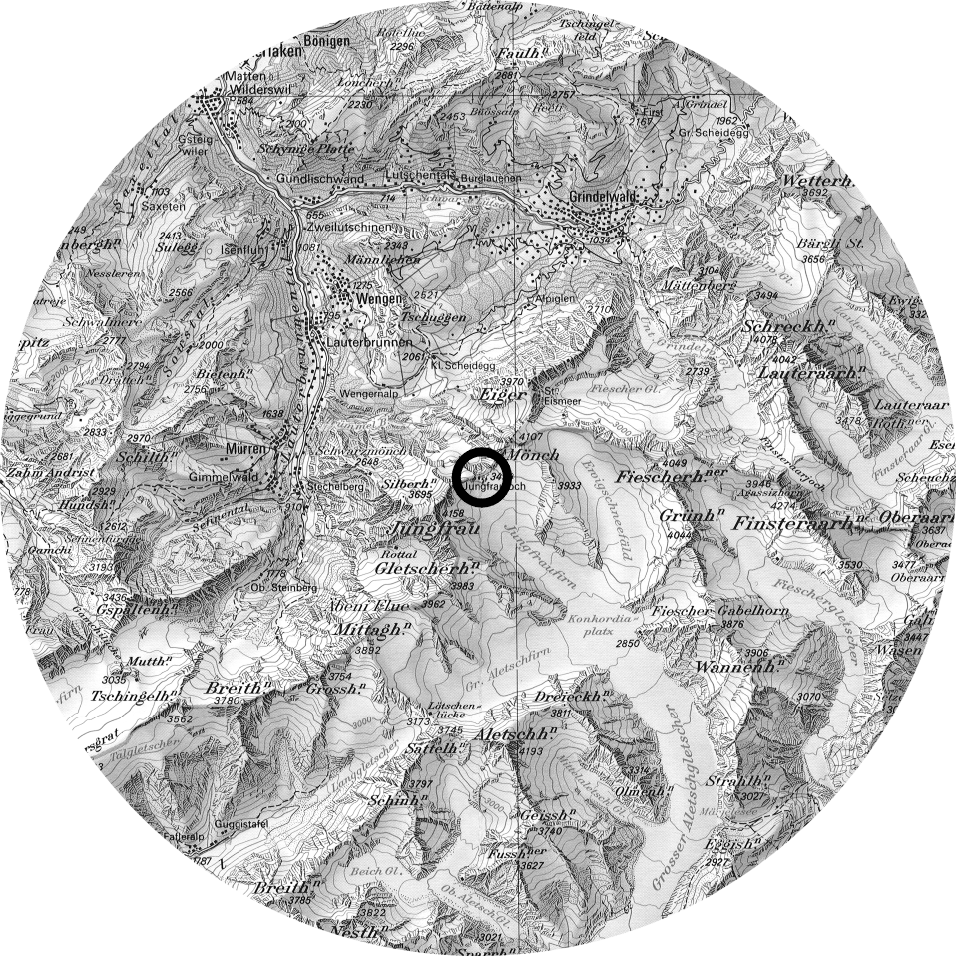
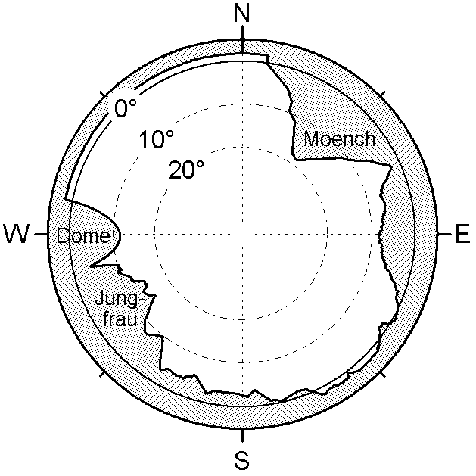
Fig. 1. Topographical map of the surrounding of the High Alpine Research Station Jungfraujoch (left; printed with the permission of the Bundesamt fuer Landestopographie, Wabern, Switzerland) and the horizon seen from the instrument’s location (right).

Fig. 2. Correction of polarisation effects applied to sky radiance data calculated by a one dimensional discrete ordinate model, shown for the principal plane (top) and along the solar almucantar (bottom).

Fig. 3. Sensitivity of model results for normalised radiance values in the forward scattering direction of the principal plane, as used in expression (1), to surface albedo . The sensitivity is expressed by the ratio of calculated normalised radiance for a model albedo value of 0.7 to the corresponding values for a model albedo of 0.9.
Fig. 4. Comparison between measurements of sky radiance at 350 nm in the principal plane (thick line), performed on 24 May 2000 at the Jungfraujoch (Switzerland, 3576 m a.s.l.), and corresponding model calculations for homogenously snow covered ground (shaded area). The data are normalised according to expression (1). The uncertainty range of model calculations results from uncertainties in the predefined model parameters (see Table 2). The dashed line shows a representative model result for snow free terrain (aerosol optical depth = 0.04; aerosol single scattering albedo = 0.9; aerosol asymmetry factor = 0.677; ground albedo = 0.4), scaled by the normalisation factor derived for the corresponding model results for snow covered terrain (ground albedo = 0.838, other parameters remaining the same).
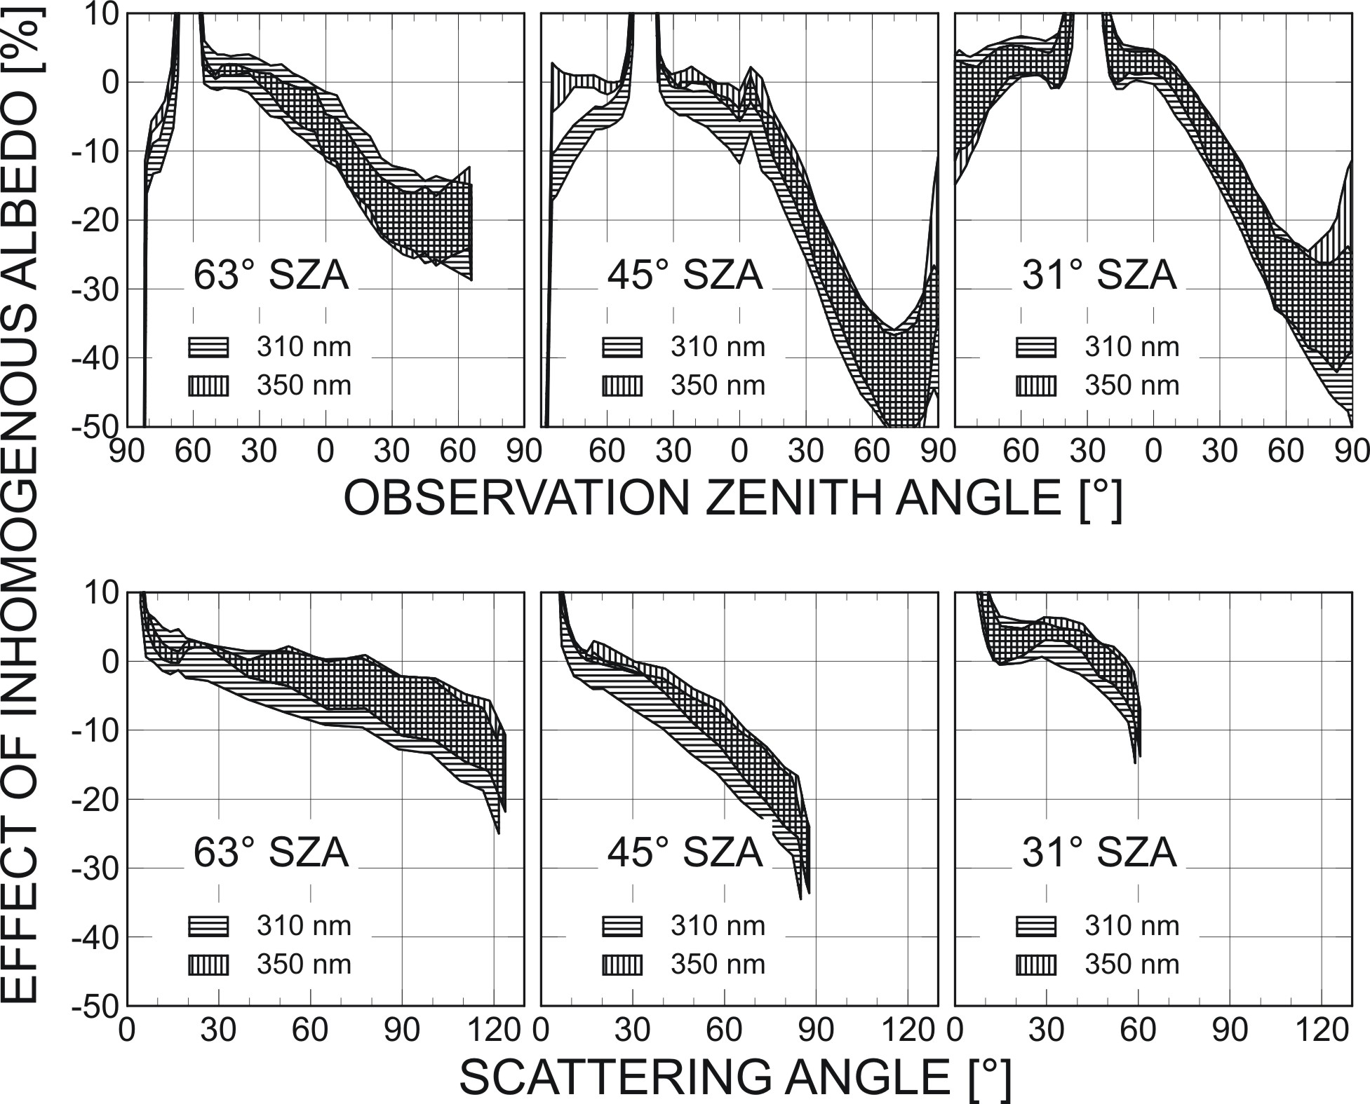
Fig. 5. Effect of snow free terrain towards Northwest on sky radiance at 310 nm and 350 nm from the principal plane (top) and along the solar almucantar (bottom), expressed by the deviation of measurement data from model calculations of corresponding data at a hypothetical situation with homogenously snow covered ground (see Fig. 4). Uncertainty ranges result from uncertainties in the predefined model parameters (see Table 2).

