EDUCE. WP 8. Deliverable 8.3.

Review of the work done in other wavelenth ranges with 3D models and the results obtained for variable cloudiness.
++++++++

1.Introduction.

Most radiative transfer models assume a plane-parallel atmosphere. This assumption is not valid in the following cases:

i) When the sun is low over the horizon or when limb observations are concerned, i.e. when the Earth's curvature needs to be taken into account. The case of low sun is now conveniently handled with the so-called "pseudo-spherical" approximation, which has been introduced in most radiative transfer codes, and gives good results at least for solar zenith angles as large as 88°. Limb observations are out of our domain of interest.

ii) When the Earth's surface reflectance is strongly inhomogeneous. In the ultraviolet (UV) range, this is the case for partial snow coverage and for variable topography, as in mountaineous areas. This subject has been analyzed for irradiance at the Earth's surface level within the European project CUVRA (Characteristics of the UV Radiation field in the Alps), combining measurements and 3-D modelling.

iii) In the presence of extended but horizontally inhomogeneous clouds, and even more, of finite clouds. We will often speak of broken clouds or variable cloudiness; however we must keep in mind that extended stratiform clouds are not at all plane-parallel layers, but have internal variations of their optical characteristics, as well as bottom and top altitude variations. Clouds are the main modulators of the radiation field at the Earth's surface and at the top of the atmosphere, both in the solar and in the longwave range, and numerous studies have been devoted to the subject of inhomogeneous cloudiness.

Actually the same 3-D radiative transfer codes apply to both cases ii) and iii). However each problem, and especially in the cloud case, is so complex that each paper generally concerns a specific aspect and cannot easily be extrapollated to other aspects. Moreover an important difference exists between the problems of an inhomogeneous surface and of an inhomogeneous cloud, as the surface remains constant, over time periods of days, or at least of hours (case of snow falls), whereas the cloud cover can vary very rapidly, leading to statistical approaches.

Our purpose in this review is to seek what methods and/or results could apply to our specific problem of UV radiation at the Earth's surface in cloudy cases. Of course such a review cannot pretend to be exhaustive, as a huge number of papers has been devoted to this topics since about three decades. It is also somewhat arbitrary, and the choice made of a few among many papers definitively reflects the author's personal judgment.

Section 2 presents the usual objectives of 3-D cloud studies and section 3 the evolution of 3-D modelling. The Monte Carlo technique is summarized in section 4, with some examples of results obtained by this method. Section 5 is devoted to some recent promising analytical methods. Section 6 presents the stochastic approach with some results.

2.Problems and objectives of the 3-D cloud studies.

Clouds are called inhomogeneous if their optical parameters present horizontal gradients. This can be due either to cloud geometry ( number and spatial distribution of individual clouds, finite horizontal extend, irregular cloud shapes), or to macroscale fluctuations of liquid water content, particle size distribution, phase composition. The second type of inhomogeneity appears even in cloud which are geometrically plane-parallel as extended stratus, and is the subject of several papers (Galinsky and Ramanathan, 1998; Cairns et al., 2000).
The second type of inhomogeneity is certainly more spectacular, and it is generally referred to as "broken clouds"; the best exemple is provided by cumulus clouds.

Two major objectives appear in the 3-D cloud studies:
One concerns climate, with the question "what is the effect of unresolved horizontal variability in cloud stucture on energy budget in General Circulation Models (GCMs)", as the cloud structures are generally smaller than the model grid. A particular concern is the absorption and the heating rate in cloudy area. Comparisons of in situ observations with plane-parallel cloud models have shown an extra "anomalous" absorption, and various theories have been proposed for explaining this absorption; the effect of cloud structure is one among these theories (O'Hirok and Gautier, 1998; Cairns et al., 2000; Fu et al., 2000).

The second objective concerns remote sensing of cloud properties which are based on the plane-parallel theory and neglect the internal variability inside clouds at the satellite pixel scales. Therefore many papers consider only the albedo or the reflected radiance (Kobayashi,1988; Varnai and Davies, 1999), and their application to the radiation transmitted at the Earth's surface is not obvious.

3.Methods of 3-D cloud modeling. Historic and present situation.

Due to the simplicity of 1-D radiative transfer models, the first idea is to try defining a plane-parallel cloud "equivalent" to the inhomogeneous cloud over the whole scene, generally based on some averaging of the optical depth. A better approach is the so-called "independent pixel approximation" (IPA) or "independent column approximation" (ICA), which considers a different equivalent plane-parallel cloud for each pixel (eventually no cloud for clear pixels), and average the computed reflectance, transmittance or absorption for the whole scene (Cahalan et al.,1994b). This approach neglects the horizontal photon transport between columns. A modification called "tilted independent pixel approximation" (TIPA) is proposed by Varnai and Davies (1999).

A first distinction is to be made between methods which consider a fixed isolated cloud, or a fixed distribution of clouds, and methods which consider a stochastic distribution of clouds and search for statistical characteristics of the radiation field.
A second distinction is between the Monte Carlo method, which can handle any type of geometry and which has been (and still is) widely used in 3-D radiative transfer problems, and the more "analytical" methods which rely on extension of 1-D methods; they can be approximate and fast, but they also require a lot of numerical computations, if they are expected to compete in accuracy with Monte Carlo codes.

The interest in 3-D radiative transfer has really started in the early seventies; as the Monte Carlo method was very time consuming on the computers of this time, only simple cloud geometry were considered (Aida, 1977, Van Blerkom, 1971). Meanwhile, approximate, but much faster, analytical methods were developped; they rely on Delta-Eddington approximation in 3-D, or on expansion in spherical harmonics functions limited to one term. These methods were checked against Monte Carlo results (Davies, 1978) and lead to interesting results; however they have not much interest nowadays. A review of the early work can be found in the book "Radiative transfer in scattering and absorbing atmospheres: standard computational procedures" edited by Lenoble (1985) under the auspices of the Radiation Commission of IAMAS.

During the last two decades, development of 3-D modelling has mainly followed the computer developments, and has become on itself an important subject of interest for the radiation community (Davis et al., 1999). The International Intercomparison of 3-dimensional Radiation Codes or I3RC has as its primary goal to compare a wide variety of 3-D methods applied to the Earth's atmosphere, with a few selected cloud fields as input, and a few selected radiative quantities as output. During phase 1, now complete, 3 cloud fields were considered; the computations were monochromatic, and involved cloud and surface only. About 15 research groups representing several countries took part in phase 1. A volume of abstracts on I3RC effort is in preparation (Cahalan, 2001), and results of the intercomparison are available on the I3RC web page (http:\\i3rc.gsfc.nasa.gov\). More extended comparisons will be performed during phases 2 and 3, with a few more participants.
The present review may certainly need updating in the coming years.

4.The Monte Carlo method.

In a Monte Carlo computation (Marchuk et al., 1980), one photon is followed at a time on its 3-D path through the atmosphere. The various events which may happen to the photon are defined by suitable probability distributions. A set of random numbers is then used to make a particular choice for the result of each event.

The simplest analysis considers an isolated cloud; this allows the understanding of the cloud side effect in comparison with an infinitely extended cloud. McKee and Cox (1974) have considered cubic isolated clouds with no atmosphere around them; the dimensions are expressed in term of vertical or horizontal optical thickness, which correspond to different geometric dimensions depending on the liquid water content; the cloud model is type C1 from Deirmendjian (1969). Their results are summarized in figure 6 of their paper (here figure 1). They show that for the same incoming radiation per unit area, there is less reflected and more transmitted radiation than for an infinite cloud, because radiation escaping from the sides, is larger downwards than upwards. For high sun the contribution of the sides to the total downward flux is about 50% for small optical depths and it represents almost all the transmitted flux for large optical depths. The results are sensitive to the solar zenith angle; for low sun and small optical depth, most of the contribution comes from the side opposite to the sun, because of the strong forward scattering of cloud particles.

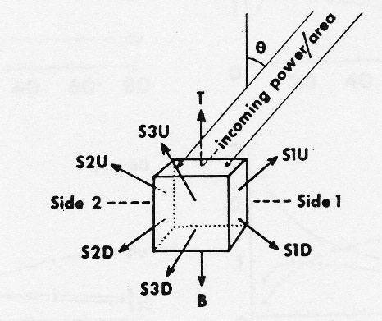
FIG. 6. Schematic diagram for cubic cloud and fraction of incident light scattered from top, bottom and sides into upward and downward hémisphères.

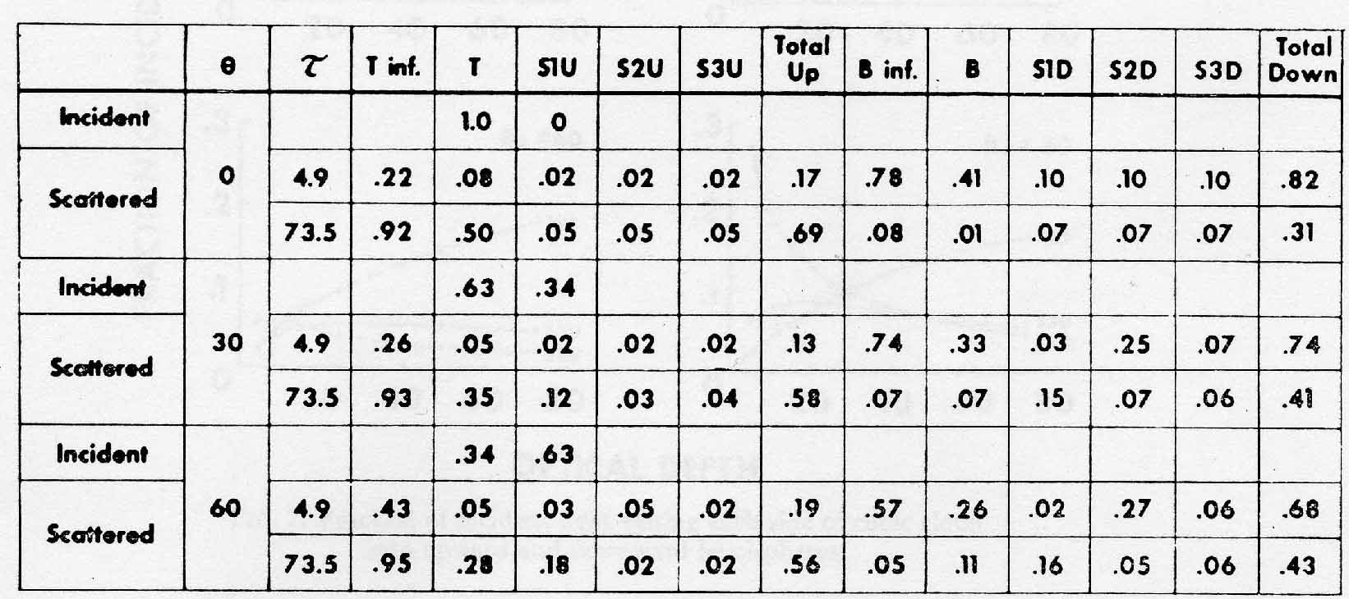

Figure 1. From McKee and Cox, 1974.

McKee and Klehr (1977) have extended the study to two superposed isolated cuboids illuminated from the zenith. Welch and Zdunkowski (1981) have compared isolated cubic, rectangular, hemispherical, cylindrical, and cylindrical with hemispherical top clouds; the results are integrated over the whole solar spectrum and concern clouds with base diameter equal to heigth, located at 500 m. The shape effect on reflectance, transmittance and absorption is rather important; it depends on the cloud thickness and most likely on the other characteristics choosen for the clouds. Welch and Wielicki (1984) consider a regular array of identical clouds with different shapes, but they present results only for the reflectance.

Cairns et al. (2000) consider a cloud with horizontal variability of extinction, and compare the Monte Carlo 3-D results with independent pixel and plane parallel approximation. Results are given for absorption and spherical albedo in figure 2 of their paper (here figure 2), versus the average optical depth of the cloud. Their figure 3 (figure 2) shows that for a fixed spherical albedo (as it can be observed from satellite), the absorption is not the same for the three models.

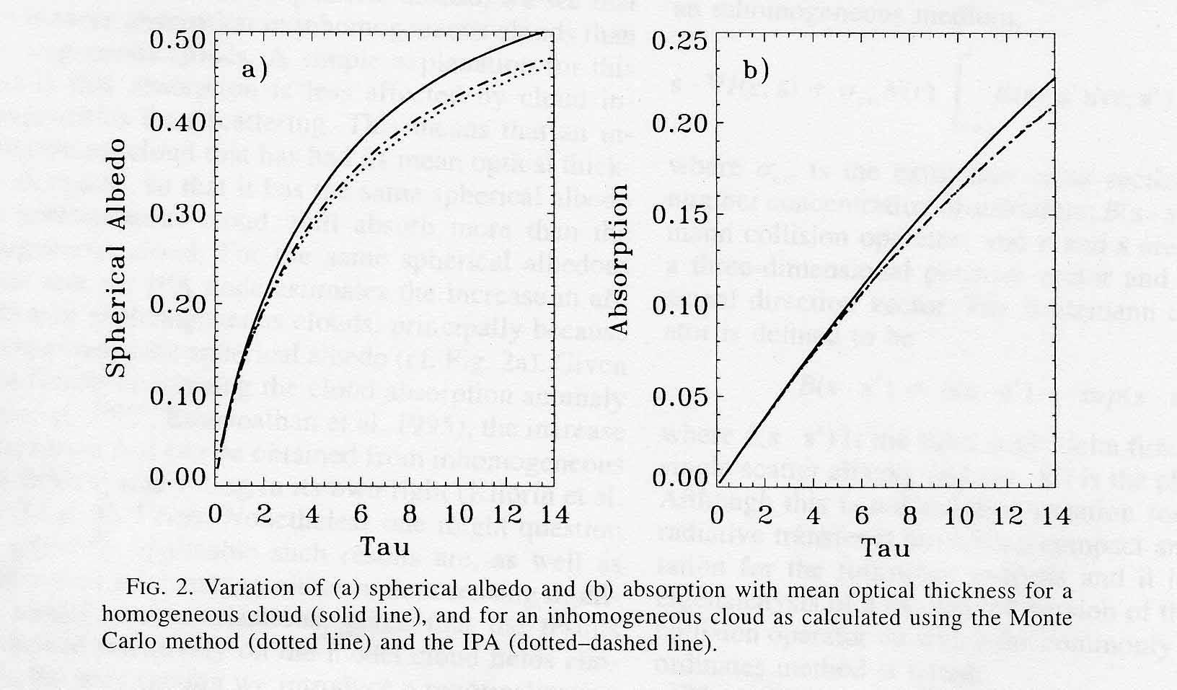

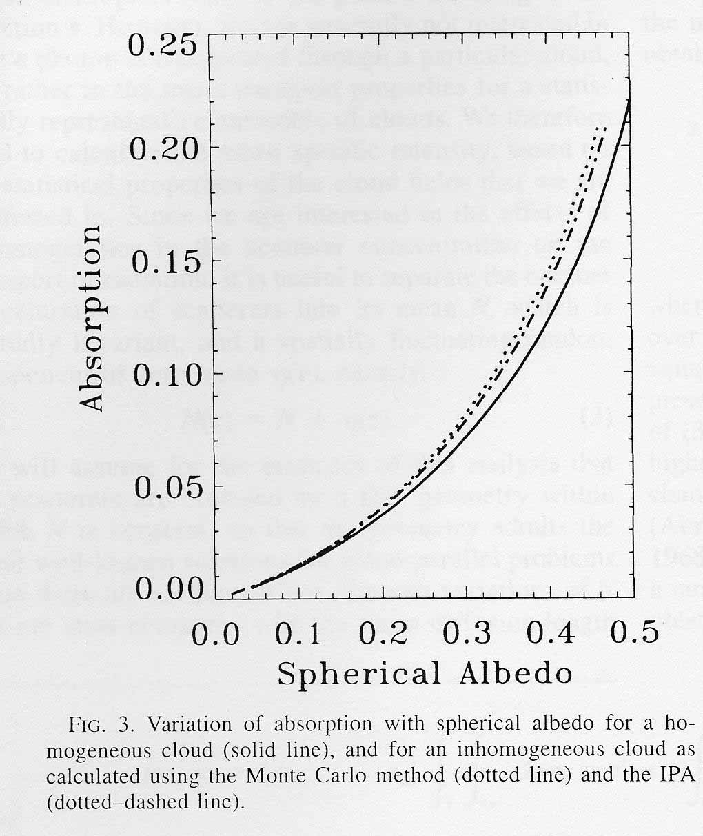Figure 2. From Cairns et al., 2000.
O'Hirok and Gautier (1998) uses a Monte Carlo code of high spectral and spatial resolution; it includes Rayleigh scattering, absorption and scattering by cloud droplets and aerosols, and absorption by the major atmospheric gases, between 0.25 and 4.0 µm. The 3-D cloud model is derived from an AVHRR (Advanced Very High Resolution Radiometer) on NOAA-14 image. The actual computation time was on the order of a few weeks. The same code was also run in the independent pixel mode (IPM) and in the plane parallel mode (PPM). Figure 5 of their paper (here figure 3) compares the IPM with the exact 3-D mode (3DM); 3DM gives more downwelling flux at the surface and more absorption, with less upwelling flux at the top of the atmosphere. The authors make the remark that it is difficult to select a single plane-parallel cloud layer, that portray a 3-D liquid water distribution. Therefore they chose to compare their 3DM results with several different plane-parallel models currently used; in 5 of the 6 cases considered, the 3DM increases surface radiation and absorption, and reduces albedo, in comparison with the PPM. In part II of their paper, the authors analyze the spectral effects; in the UV and visible, for overhead sun, the 3DM transmission is enhanced by as much as 20%; for the 60° solar zenith angle, the transmission is greater by 5-10% in the UV and visible. However the authors are mostly interested in 3-D effects on absorption, most important in near IR bands.

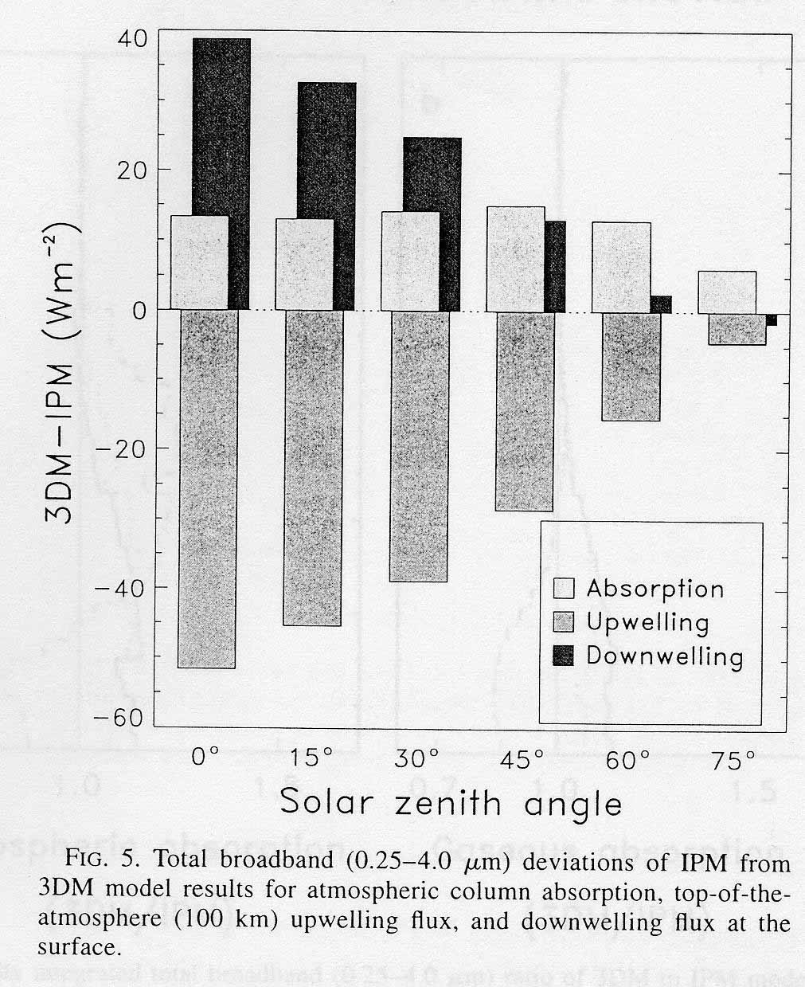
Figure 3. From O Hirok and Gautier, 1998.

5.Analytical methods.

These methods derive from methods used in 1-D radiative transfer and solve the equation of radiative transfer (RTE).
The RTE can actually be written in the quite general form

dI(r,s) /ds= σ(r) (I(r,s) – J(r,s))

for the radiance I at a position r in a direction s; σ is the extinction coefficient and J the source function, expressed by an integral over the direction of the radiance at each point. In a 3-D medium, this leads to an integro-differential equation with 3 partial derivatives over the 3 space coordinates.
A method consists in Fourier transforming the horizontal spatial dependencies to the spectral domain (Stephens, 1988; Gabriel et al., 1993); this converts the original equation to a set of ordinary differential equations, which can be solved with the methods used in the 1-D case.

For the methods in which the horizontal variables are treated directly, the finite difference scheme is employed to approximate the partial differenciation. The angular distribution is taken care of, either by the discrete ordinate method ( Sanchez et al., 1994) or by the spherical harmonic method (Evans, 1993).

The integral form of the RTE gives the radiance as an integral of the source function over the slant path length. Kuo et al. (1996) solves this integral equation in a 3-D lattice, based upon the Picard iteration method. This approach has similarities with the successive orders of scattering method, but the convergence is much faster, because a single iteration at a node which is n layers from a boundary incorporates the effects of up to n successive scattering events.

Evans (1998) has expanded his previous spherical harmonic spatial grid method (Evans, 1993), combining both spherical harmonics and discrete ordinate methods into the SHDOM. The spherical harmonics are employed for computing the integral which defines the source function. The discrete ordinates are used to integrate the radiative transfer equation spatially. The solution is therefore iterating between the source function and radiance field, which amounts to a successive orders of scattering approach. The discrete grid, which represents the spatial variation of the fields, is adaptative, so that extra resolution is provided when necessary. The SHDOM code is available to the scientfic community, which makes it the most attractive among the analytical methods. The author concludes that the choice between Monte Carlo and SHDOM depends on the particular problem to be solved. When only a few quantities are needed the advantage is to Monte Carlo, which is faster. SHDOM, as other analytical methods, provides the whole radiation field and any desired radiative quantity may be computed at little extra cost.

6.Stochastic methods.

Cloudiness formed as a result of atmospheric dynamical processes, is stochastic and the radiation field will have as the cloud system a random irregular structure. The idea, underlying this type of methods, is that in practice the quantity required is the average of the radiation field over the ensemble of cloud realizations. Most of the early work has appeared in russian publications (Avaste and Vainikko, 1974); it is summarized and further references can be found in Lenoble (1985).

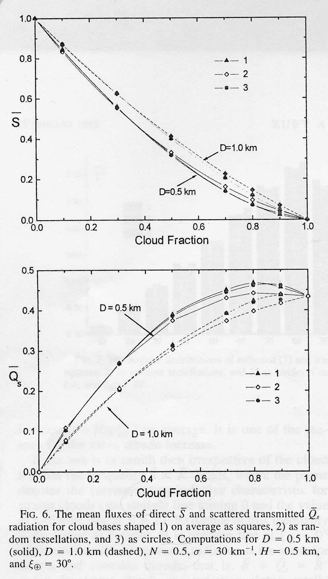

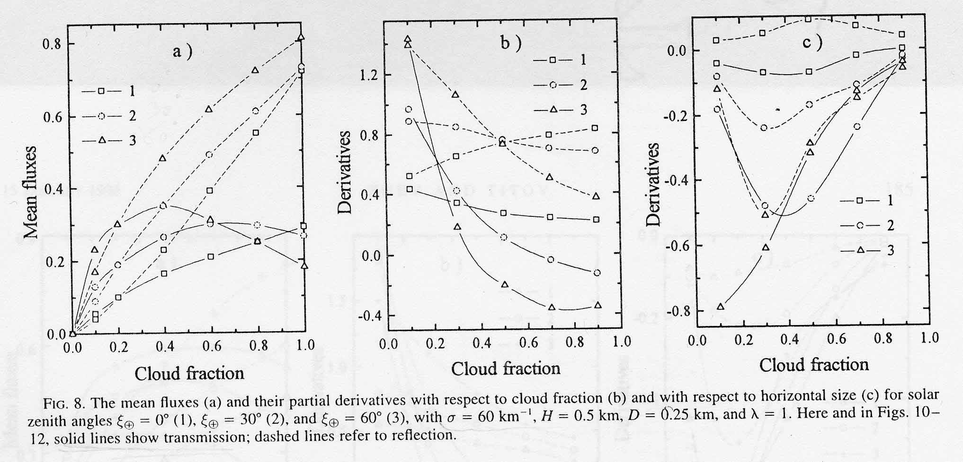

Figure 4. From Zuev and Titov, 1999.
Titov (1990) presents the mathematical details of the stochastic radiative transfer solution and consider two approaches. One method consists in applying the Monte Carlo Method to different realizations of the cloud field and averaging the obtained solutions over the ensemble. This was very time consuming in the late 1980s, and another much faster, but approximate method is proposed; it derives a closed system of equations for radiance moments; the limits of applicability are discussed and some results presented.

Zuev and Titov (1999) have extended the same approach and present more results. The scattering properties of the cloud are specified and remain constant inside the clouds, and statistical independence and homogeneity are assumed. The cloud models are generated by the Poisson point fluxes in space; clouds have the same height H and their centers are located in the same plane h; they are approximated by cylinders with various basis. Results are given for C1 cloud phase functon (Deirmendjian, 1969) at 690 nm; the cloud is non absorbing; the Earth's surface is black. Other characteristics are the extinction coefficient σ, the horizontal dimension expressed as the diameter D of the basis equivalent circle, and the cloud fraction N. The solar flux incident on the cloud top is taken as unity; Rayleigh and aerosol scattering are neglected. Their figure 6 (here figure 4) shows that the shape of the cloud basis has a very small impact on the direct and on the diffuse mean irradiance. Figure 8a (figure 4) presents the mean reflected and diffusely transmitted fluxes versus the cloud fraction (N=1 corresponds to stratus) for 3 SZAs. For low sun, radiation emerging from the cloud sides, mostly downward because of the strong forward peak of the phase function, is important; therefore the diffusely transmitted flux is larger than for stratus; at large cloud fraction this effect is weaker due to the interactions between clouds. The authors also analyze the partial derivatives of the mean fluxes; they conclude that the primary parameters governing the solar radiation in statistically homogeneous fields of cumulus cloud is the cloud fraction and the cloud horizontal size.

Geogdzhaev et al. (1997a) represent the stochastic structure of cloud fields by a collection of fixed instances. The mean characteristics of the radiation field are calculated using Monte Carlo technique. The broken cloud field is assumed at a given level in the otherwise homogeneous atmosphere; it is defined by a two-dimensional array of numbers which gives the cloud top altitude. The optical properties of clouds are taken from Feigelson (1981). The input parameters to the model are zenith cloud amount n_{0,} mean cloud height H, mean diameter of cloud base D; aspect ratio is defined as k=H/D. Their figure 2 (here figure 5) presents the ratio C_{q} of irradiance in cloudy and clear sky conditions versus the zenith cloud amount, with H and k representative for the European part of Russia, and for several values of surface albedo. When the Earth's surface is highly reflecting the presence of clouds enhances the irradiance at the surface level, because of the multiple reflectances between the surface and the cloud.
For a cloud amount of 0.5, and clouds of equal height located at 1 km., the authors have compared the approximation Fcloudy= 0.5 (Fclear + F overcast), where Fclear and Fovercast are given by the plane-parallel approximation, with the value computed by their method. Figure 3 (figure 5) shows the result of this comparison for SZA=60° and various surface albedos; generally the approximation underestimates the cloud transmittance, due to the effects of cloud sides.

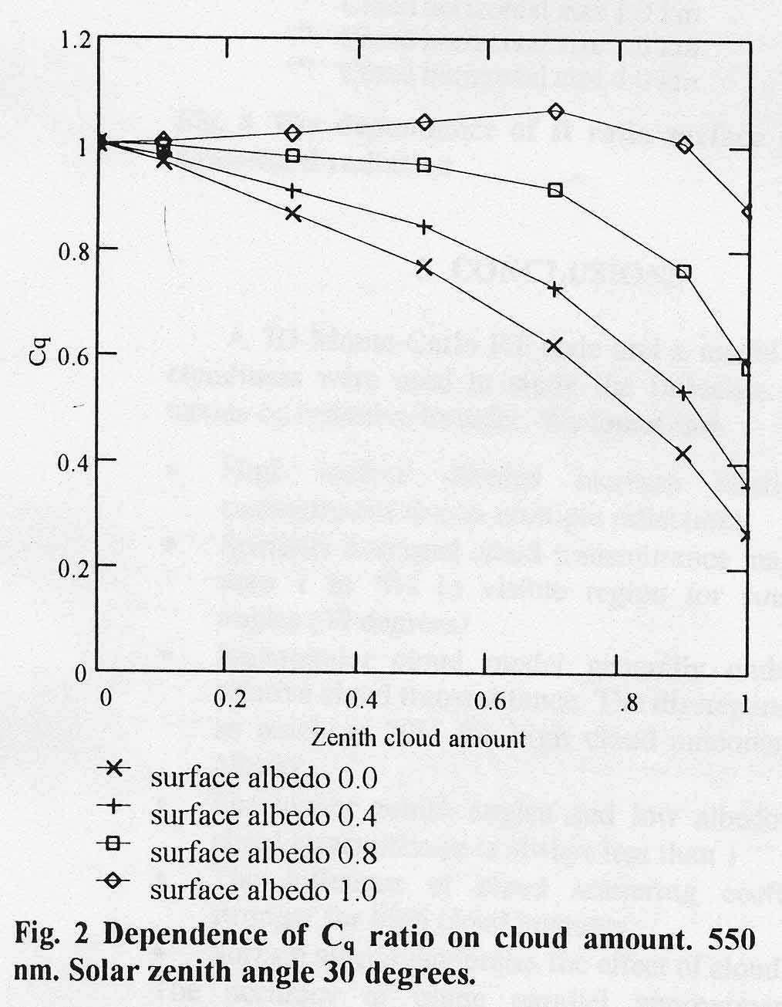

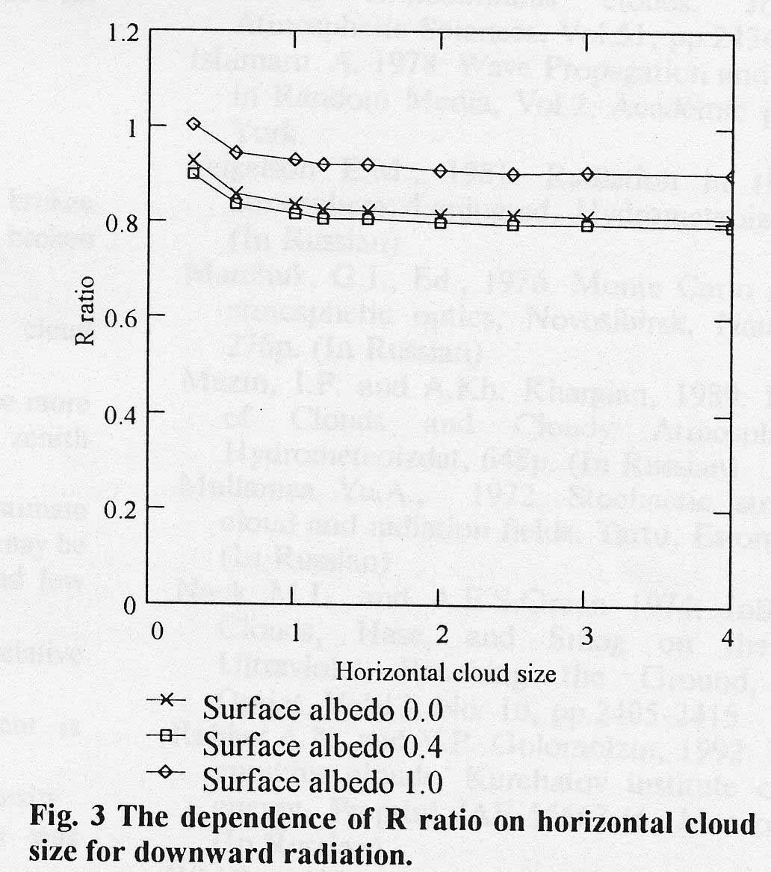

Figure 5. From Geogdzhaev et al., 1997a.

Geogdzhaev et al. (1997b) apply the same method to UV radiation; they relate the zenith cloud amount n₀ to the observed cloud amount n through the empirical relation: n=10(0.1n₀+0.8 (1-0.1n₀)(0.1n₀)^{0.8} (Feigelson, 1981). Figure 3 of the paper (here figure 6) presents the dependence of cloud transmittance on cloud aspect ratio; it can be rather large. Figure 4 (figure 6) gives the mean spectral transmittance of broken cloudiness, and figure 5 (figure 6) its dependence on the SZA. For average conditions of broken cloudiness as considered here, the cloud transmittance is never larger than 1, although local enhancements are often observed.

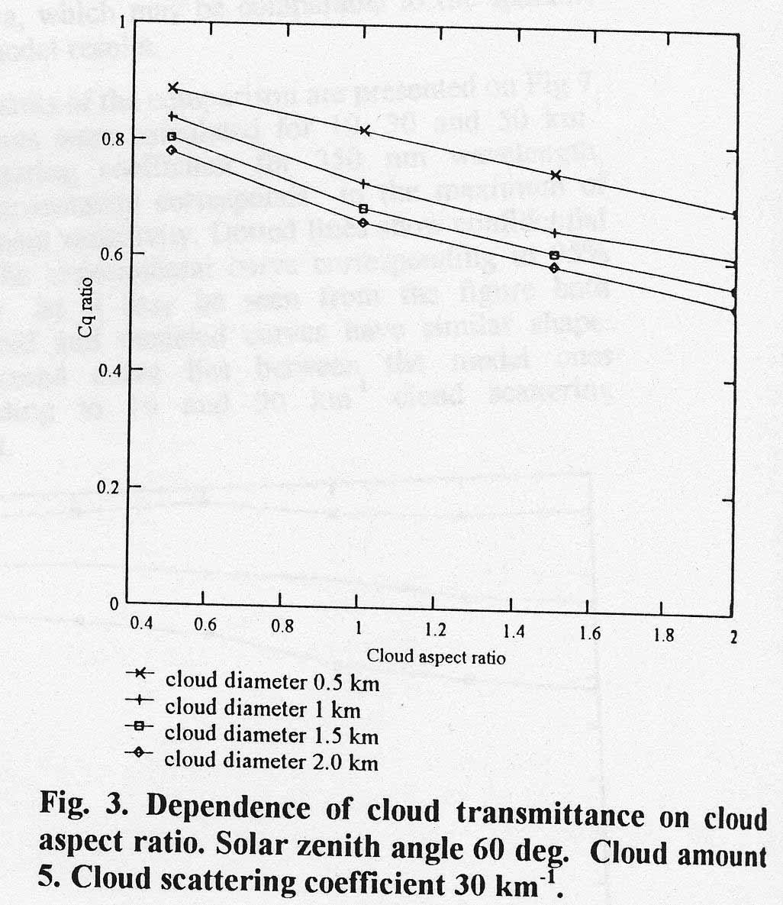
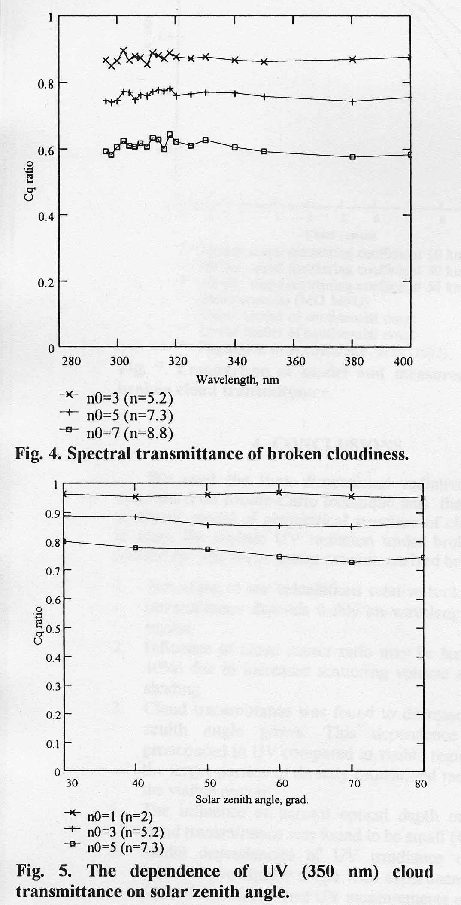

Figure 6. From Geogdzhaev et al., 1997b.

The fractal approach is based on the analysis of turbulence; the energy entering the atmospheric system on large scales is transferred to the smaller scales in a cascade process. Observed energy spectra of cloud liquid water content are scale invariant (or scaling), i.e. clouds are fractal. This result supports the idea that clouds have no characteristic length over a wide range, and the same is true for the radiative field; the radiance depends only on the dimensionless optical thickness. However clouds are turbulent fields which interact with radiation field down to scales of the order of millimeters, and they have multiple fractal dimensions. Clouds and radiation in a cloudy atmosphere are multifractal fields. A lot of work has been done on radiative transfer in multifractal media (Lovejoy et al., 1990; Schertzer and Lovejoy, 1991) and this seems a very promising approach; however it is difficult to apply without a good background in fractal theory. Cahalan et al. (1994a) have analyzed the albedo of stratocumulus clouds with horizontal variations of the water content; the clouds are defined by a "bounded cascade" fractal model and the albedo is computed for each realisation by the IPA method. Computing the albedo for a plane-parallel cloud, with the same amount of total liquid water content uniformly distributed, leads always to a positive bias reaching 10 to 15%. In a following paper, Cahalan et al. (1994b)

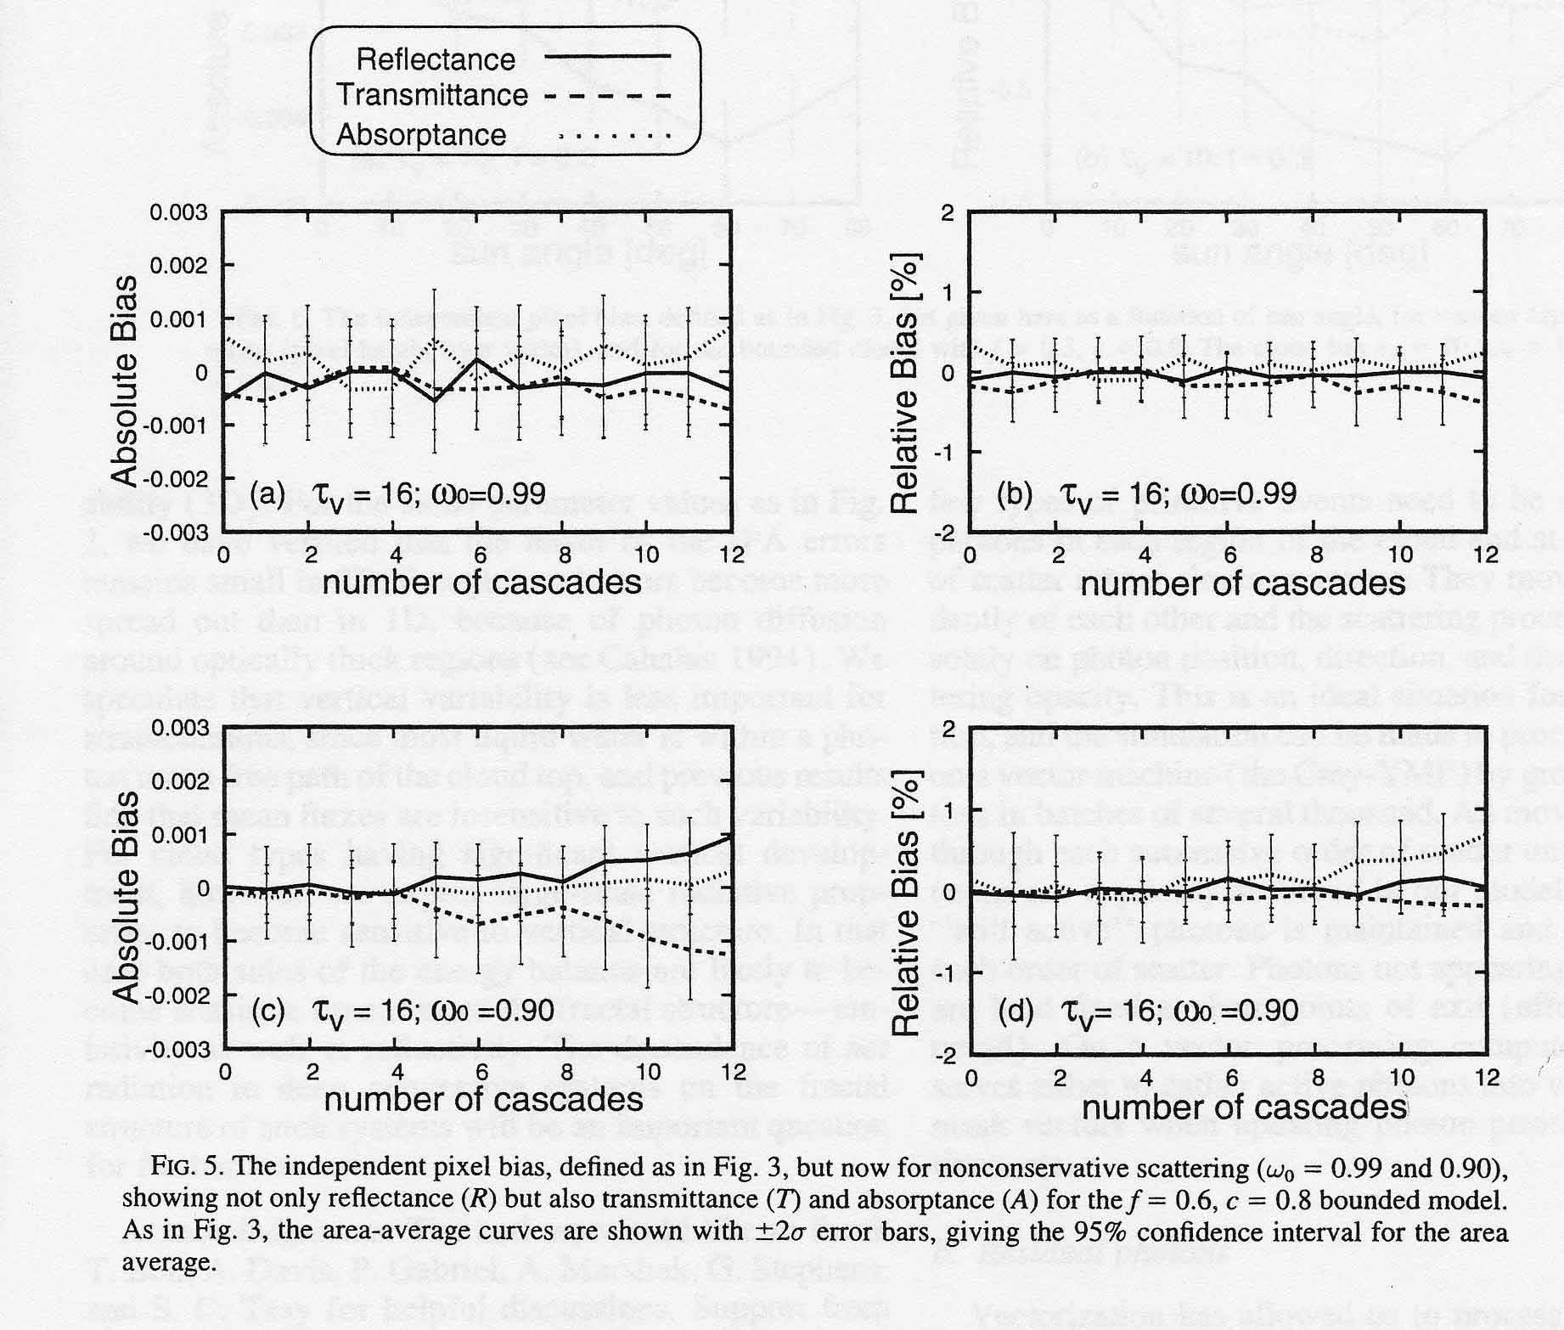

Figure 7. From Cahalan et al., 1997b.

compare the IPA method with Monte Carlo computations, and find that the IPA does not give bias larger than 1%, for fluxes averaged over large horizontal areas. Their figure 5 (here figure 7) presents the bias on reflectance, transmittance and absorptance, versus the number of cascades in the model.

7.Conclusion.

This review has voluntarily been limited, as hundred of references could probably be quoted. We hope that it gives an idea of the strong interest devoted, since about three decades, to the problem of inhomogeneous cloudiness, and of the present active developments. The pioneering works in the early seventies considered only very simplified models, but have given important insights in the problem. Nowadays, one can solve very accurately the equation of radiative transfer in almost any complex geometry, either with Monte Carlo method, or with new emerging methods, as SHDOM. However the necessary computer ressources and the computation time remain a limitation to a frequent usage of such codes.

The main reasons for improving radiative transfer computations in inhomogeneous cloudiness are either in a better analysis of cloud effects in General Circulation Models, or in improving remote sensing of cloud characteristics. These objectives require stochastic representations of clouds.

Keeping in mind our main interest in UV irradiance at the Earth's surface, the question we must ask to ourselves is "what are we planning to do with radiatve transfer modelling in 3-D clouds ?". Comparisons between measured and computed irradiances, which proved very instructive in cloudless cases, are probably meaningless. Assuming we may have instantaneous mesurements of the whole spectrum and therefore avoid variation of the conditions during the spectral scan, we would further need a complete description of the cloud geometry and characteristics as input into the model.
Results available in the litterature are generally not directly applicable to our problem; but most papers conclude that an inhomogeneous cloud layer transmits more radiation to the surface than an homogeneous cloud with the same liquid water content. An interesting finding is that a plane-parallel cloud equivalent to the inhomogeneous cloud cannot be defined to give simultaneously the same transmittance, reflectance and absorption; however the equivalence seems possible when only one of these quantities is considered, i.e. the transmittance.
A possible direction for our studies would be the analysis of time averaged irradiance, with climatological statistical description of clouds.

References

Aida, M. (1977): Scattering of solar radiation as a function of cloud dimensions and orientation. J. Quant. Spectrosc. Radiat. Transfer, 17, 303-310.

Avaste, O.A., and G.M. Vainikko (1973): Solar radiative transfer in broken clouds. Izv. Acad. Sci. USSR, Atmos. Oceanic Phys., 10,1054-1061.

Cairns, B., A.A. Lacis, and B.E. Carlson (2000): Absorption within inhomogeneous clouds and its parametrerization in General Circulation Models. J. Atmos. Sci., 57, 700-714.

Cahalan, R.F., W. Ridgway, W.J. Wiscombe, T.L. Bell, and J.B. Snider (1994a): The albedo of fractal stratocumulus clouds. J. Atmos. Sci., 51, 2434-2455.

Cahalan, R.F., W. Ridgway, W.J. Wiscombe, S. Gollmer, and Harshvardhan (1994b): Independent pixel and Monte Carlo estimates of stratocumulus albedo. J. atmos. Sci. 51, 3776-3790.

Cahalan, R.F. (Edit.) (2001): The International Intercomparison of 3-dimensional Radiation Codes. To appear.

Davies, R. (1978): The effect of finite geometry on the three-dimensional transfer of solar irradiance in clouds. J. Atmos. Sci., 35, 1712-1720.

Davis, A.B., A. Marshak, E. Kassianov, and G.M. Stokes (1999): Three-Dimensional radiative transfer makes its mark. EOS, 51, 622 and 624.

Deirmendjian, D. (1969): Electromagnetic radiation scattering on spherical polydispersions. Elsevier, New York, 290 pp.

Evans, K.F. (1993): Two-dimensional radiative transfer in cloudy atmospheres: The spherical harmonic spatial grid method. J. Atmos. Sci., 50, 3111-3124.

Evans, K.F. (1998): The spherical harmonics discrete ordinate method for three-dimensional atmospheric radiative transfer. J. Atmos. Sci., 55, 429-446.

Feigelson, E.M. (1984): Radiation in a cloudy atmosphere. Reidel, Dordrecht, The Netherlands, 293 pp.

Fu, Q., M.C. Cribb, H.W. Barker, S.K. Krueger, and A. Grossman (2000): Cloud geometry effects on atmospheric solar absorption. J. Atmos. Sci., 57, 1156-1168.

Gabriel, P.M.,S.C. Tsay, and G.L. Stephens (1993): A Fourier-Riccati approach to radiative transfer. Part I: Foundations. J. Atmos. Sci. ,50, 3125-3147.

Galinsky, V.L., and V. Ramanathan (1998): 3D Radiative transfer in weakly inhomogeneous medium. Part I: Diffusive approximation. J. Atmos. Sci., 55, 2946-2959.

Geogdzhaev, I.V., T.V. Kondranin, and A.N. Rublev (1997a): A radiative transfer model for broken cloudiness conditions. in "IRS'96: Current problems in atmospheric radiation", edit.by W.L. Smith and K. Stamnes, A. Deepak Publ., Hampton, VA, USA, 151-154.

Geogdzhaev, I.V., T.V. Kondranin, N.E. Chubarova, and A.N. Rublev (1997b): Comparison of UV measurements and modelling under broken cloudiness. in "IRS'96: Current problems in atmospheric radiation", edit.by W.L. Smith and K. Stamnes, A. Deepak Publ., Hampton, VA, USA, 865-868.

Kobayashi, T. (1988): Parameterization of reflectivity for broken cloud fields. J. Atmos. Sci., 45, 3034-3045.

Kuo, K.S., Weger, R.C., Welch, R.M., and S.K. Cox (1996): The Picard iterative approximation to the solution of the integral equation of radiative transfer- Part III. Three-dimensional geometry. J. Quant. Spectrosc. Radiat. Transfer, 55, 195-213.

Lovejoy, S., A. Davis, P. Gabriel, D. Schertzer, and G. L. Austin (1990): Discrete angle radiative transfer. 1. Scaling and similarity, Universality and diffusion. J. Geophys. Res., 95, 11699-11715.

Lenoble, J. (Edit.) (1985): Radiative transfer in scattering and absorbing atmospheres: Standard computational procedures. A. Deepak Publ., Hampton, Va;, USA, pp.300.

Marchuk,G.I., G.A. Mikhailov, M.A. Nazaraliev, R.A. Darbinjan, B.A. Kargin, and B.S. Elepov (1980): The Monte Carlo methods in atmospheric optics. Springer Verlag, Berlin, Heidelberg, New York, 208 pp.

McKee, T.B., and S.K. Cox (1974): Scattering of visible radiation by finite clouds. J. Atmos. Sci., 31, 1885-1892.

McKee, T.B., and J.T. Klehr (1977): Radiative effect of cloud geometry. In "Proc. of Symposium on Radiation in the Atmosphere 1976", edit. by H.J. Bolle, Science Press, Princeton, USA, 217-219.

O'Hirok, W., and C. Gautier (1998): A three-dimensionel radiative transfer model to investigate the solar radiation within a cloudy atmosphere. J. Atmos. Sci., 55, Part I: Spatial effects, 2162-2179. Part II: Spectral effects, 3065-3076.

Sanchez, A., T.F. Smith, and W.F. Krajewski: A three-dimensional atmospheric radiative transfer model based on the discrete ordinates method. Atmos. Res., 33, 283-308.

Schertzer, D., and S. Lovejoy (Edit.) (1991): Non-linear variability in geophysics, scaling and fractals. Kluwer, Norwell, Mass., USA, 318 pp.

Stephens, G.L. (1988): Radiative transfer through arbitrarily shaped optical media. Part I: A general method of soluton. J. Atmos. Sci., 45, 1818-1836.

Titov, G.A. (1990): Statistical description of radiation transfer in clouds. J. Atmos. Sci., 47, 24-38.

Van Blerkom, D.J. (1971): Diffuse reflection from clouds with horizontal homogeneities. Astrophys. J., 166, 235.

Varnai, T., and R. Davies (1999): Effects of cloud heterogeneities on shortwave radiation: comparison of cloud-top variability and internal heteorogeneity. J. Atmos. Sci. 56, 4206-4224.

Welch, R.M., and B.A. Wielicki (1984): Stratocumulus cloud field reflected fluxes: the effect of cloud shape. J. Atmos. Sci., 41, 3085-3103.

Welch, R.M., and W.G. Zdunkowski (1981): The effect of cloud shape on radiative characteristics. Contr. Atmos. Phys., 54, 482-491.

Zuev, V.E., and G.A. Titov (1995): Radiative transfer in cloud fields with random geometry. J. Atmos. Sci., 52,176-190.

