Results of the EDUCE questionnaire about Quality Control at spectral UV-measuring sites in Europe

In the frame of the EU-project EDUCE (European Database for UV Climatology and Evaluation) the Institute for Medical Physics at the University of Innsbruck, Austria, was appointed to make an inventory of the quality control procedures applied at spectral UV monitoring stations in Europe.
The following data were collected by means of a web-form between October 2000 and February 2001. We tried to consider as many UV working groups as possible. Eighteen institutions which are participate in EDUCE and four institutions which are not part of EDUCE gave information about their spectral measurements. The results of the questionnaire describe the knowledge available from these operators who has submitted in total 30 documents to the database.
Here you can find the address and the name of the contact person of each group.

General information about the used spectroradiometers

List of participants
 | BFS, BOKU, DWD, ENEA, FMI, IFU, INM, JRC, KNMI, LAP, MI, NILU, NRP, NTNU, RIVM, SMHI, STUK, UH, UI, UJF, UMIST, URO, USTL

Type of spectroradiometers
 |  | Instruments |  |  | 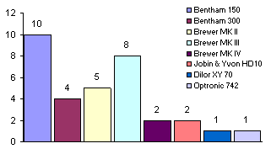
 | Bentham 150 | 10
 | Bentham 300 | 4
 | Brewer MK II | 5
 | Brewer MK III | 7
 | Brewer MK IV | 2
 | Jobin & Yvon HD10 | 2
 | Dilor XY 70 | 1
 | Optronic 742 | 1
 | 8 | 32

Frequency of spectral UV-measuring activities
 |  | Instruments |  |  | Institutes |  |  | 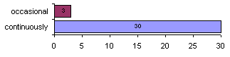
 | continuously | 29 |  |  | 20
 | occasional | 3 |  |  | 3
 | 2 | 32 |  |  | 23

Primary standard is traceable to
 |  | Instruments |  |  | Institutes |  |  | 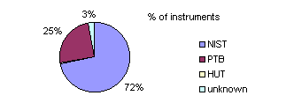
 | NIST | 23 |  |  | 17
 | PTB | 8 |  |  | 7
 | HUT | 0 |  |  | 2
 | unknown | 1 |  |  | 1
 | 4 | 32 |  |  | 27
 | Two groups have primary lamps from more than one calibration institute, but they use the NIST standard for the calibration of the spectroradiometer. One group gave no information.

Supplier of UV-lamps
 | Optronic, Giga Hertz Optik, Eppeley, General Electric, NOAA, SCI-TEC, Oriel, OmTec

Spectroradiometer is calibrated by
 |  |  | Instruments |  |  | Institutes |  |  | 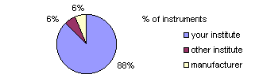
 | your institute |  | 28 |  |  | 20
 | other institute |  | 2 |  |  | 2
 | manufacturer |  | 2 |  |  | 2
 | 3 |  | 32 |  |  | 24

Stabilization of the lamp during calibration
 |  |  | Instruments |  |  | Institutes |  |  | 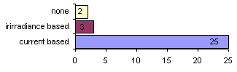
 | current based |  | 25 |  |  | 21
 | irradiance based |  | 3 |  |  | 1
 | none |  | 2 |  |  | 2
 | 3 |  | 30 |  |  | 24

Monitoring of the voltage across the lamp during calibration
 |  |  | Instruments |  |  | Institutes |  |  | 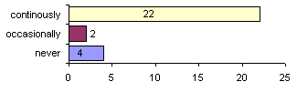
 | never |  | 4 |  |  | 3
 | occasionally |  | 2 |  |  | 2
 | continuously |  | 22 |  |  | 16
 | 3 |  | 28 |  |  | 21

Time interval for calibration of the shunt
 |  |  | Instruments |  |  | Institutes |  |  | 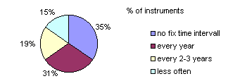
 | no fix time interval |  | 9 |  |  | 8
 | every year |  | 8 |  |  | 5
 | every 2-3 years |  | 5 |  |  | 4
 | less often |  | 4 |  |  | 3
 | 4 |  | 26 |  |  | 20

Time interval for calibration of the voltmeter
 |  |  | Instruments |  |  | Institutes |  |  | 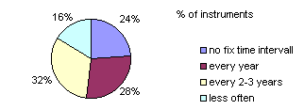
 | no fix time interval |  | 6 |  |  | 6
 | every year |  | 7 |  |  | 5
 | every 2-3 years |  | 8 |  |  | 5
 | less often |  | 4 |  |  | 3
 | 4 |  | 25 |  |  | 19

When are primary standard lamps changed?
 |  |  |  | Instruments |  |  | Institutes |  |  | 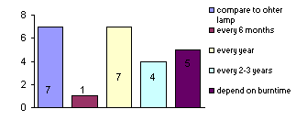
 | compare to other lamp |  |  | 7 |  |  | 6
 | every 6 months |  |  | 1 |  |  | 1
 | every year |  |  | 7 |  |  | 4
 | every 2-3 years |  |  | 4 |  |  | 3
 | depend on burn time |  |  | 5 |  |  | 4
 | 5 |  |  | 24 |  |  | 18
6 institutes compare two or more calibration lamps and
they change the lamps if differences reach a certain level.

Uncertainty estimation for calibration
 |  | Instruments |  | Institutes |  | 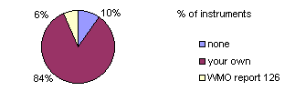
 | none | 3 |  | 3
 | your own | 26 |  | 18
 | WMO report 126 | 2 |  | 2
 | 3 | 31 |  | 23

Rough estimation of manpower for calibration of 1 spectroradiometer
 | Days per year | Instruments |  | Institutes |  | 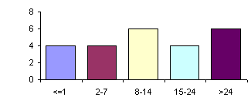
 | <=1 | 4 |  | 2
 | 2-7 | 4 |  | 4
 | 8-14 | 6 |  | 5
 | 15-24 | 4 |  | 4
 | >24 | 6 |  | 5
 | 5 | 24 |  | 20

Calibration procedure

List of 1000 Watt lamps
 | Type of lamp | Institutes |  |  |  | 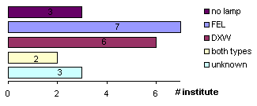
 | FEL | 7
 | DXW | 6
 | both types | 2
 | unknown | 3
 | no lamp | 3
 | 5 | 21

List of smaller lamps
 | Type of lamp | Instruments |  | Institutes
 | Set of 50W lamps | 8 |  | 6
 | 35 W or 40W lamp | 2 |  | 2
 | 100 W lamp | 1 |  | 1
 | 150 W lamp | 1 |  | 1
 | 200 W lamp | 4 |  | 3
 | 5 | 16 |  | 13

Number of calibrations of the spectroradiometer per year
 | Number per year | Outdoors |  | Indoors |  | 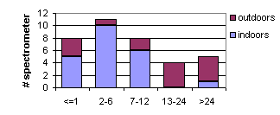
 | <=1 | 3 |  | 5
 | 2-6 | 1 |  | 10
 | 7-12 | 2 |  | 6
 | 13-24 | 4 |  | 0
 | >24 | 4 |  | 1
 | 5 | 14 |  | 22
 | Some instruments are mentioned in both columns (outside / inside)

Which type of lamp is used for calibration?
 |  |  | Outdoors |  | Indoors |  | 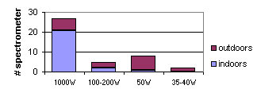
 | 1000W |  | 6 |  | 21
 | 100-200W |  | 3 |  | 2
 | 50W |  | 7 |  | 1
 | 35-40W |  | 2 |  | 0
 | 4 |  | 18 |  | 24
 | Some spectroradiometers are calibrated both with 1000W lamps and with smaller transfer lamps. Therefore the sum of used lamps does not match with the number of calibrations (table before).

Characterisation of the spectroradiometers

Angular response of the input optics is
 |  |  |  | Instruments |  |  |  | Institutes |  |  | 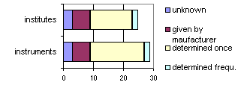
 | unknown |  |  | 3 |  |  |  | 3
 | given by manufacturer |  |  | 6 |  |  |  | 6
 | determined once |  |  | 18 |  |  |  | 14
 | determined frequ. |  |  | 2 |  |  |  | 2
 | 4 |  |  | 29 |  |  |  | 25

Wavelength accuracy is
 |  |  |  | Instruments |  |  |  | Institutes |  |  | 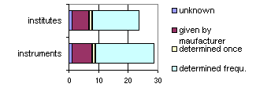
 | unknown |  |  | 1 |  |  |  | 1
 | given by manufacturer |  |  | 7 |  |  |  | 6
 | determined once |  |  | 1 |  |  |  | 1
 | determined frequ. |  |  | 20 |  |  |  | 16
 | 4 |  |  | 29 |  |  |  | 24
 | Uncertainty of wavelength adjustment to one singular wavelength.

Spectral dependence of the wavelength accuracy is
 |  |  |  | Instruments |  |  |  | Institutes |  |  | 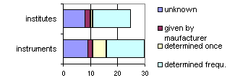
 | unknown |  |  | 9 |  |  |  | 8
 | given by manufacturer |  |  | 2 |  |  |  | 2
 | determined once |  |  | 5 |  |  |  | 1
 | determined frequ. |  |  | 14 |  |  |  | 14
 | 4 |  |  | 30 |  |  |  | 25
 | Uncertainty of wavelength adjustment depending on wavelength.

Slit function is
 |  |  |  | Instruments |  |  |  | Institutes |  |  | 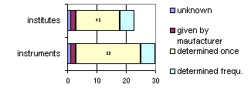
 | unknown |  |  | 1 |  |  |  | 1
 | given by manufacturer |  |  | 2 |  |  |  | 2
 | determined once |  |  | 22 |  |  |  | 15
 | determined frequ. |  |  | 5 |  |  |  | 5
 | 4 |  |  | 30 |  |  |  | 23

Temperature stabilization of the spectroradiometer
 |  |  | Instruments |  |  |  | Institutes |  |  | 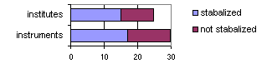
 | stabilized |  | 17 |  |  |  | 15
 | not stabilized |  | 13 |  |  |  | 10
 | 2 |  | 30 |  |  |  | 25

Dependence of output signal on temperature is
 |  |  |  |  | Instruments |  |  |  | Institutes |  |  | 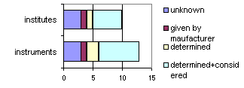
 | unknown |  |  |  | 3 |  |  |  | 3
 | given by manufacturer |  |  |  | 1 |  |  |  | 1
 | determined |  |  |  | 2 |  |  |  | 1
 | determined+considered |  |  |  | 7 |  |  |  | 5
 | 4 |  |  |  | 13 |  |  |  | 10

Dark current is
 |  |  |  |  | Instruments |  |  |  | Institutes |  |  | 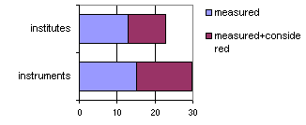
 | unknown |  |  |  | 0 |  |  |  | 0
 | given by manufacturer |  |  |  | 0 |  |  |  | 0
 | measured |  |  |  | 15 |  |  |  | 13
 | given+considered |  |  |  | 0 |  |  |  | 0
 | measured+considered |  |  |  | 15 |  |  |  | 10
 | 5 |  |  |  | 30 |  |  |  | 23
Dark current of 15 instruments is measured and not considered!
Is dark current low enough to avoid subtracting from measured signal ???

Non-linearity of the output signal is
 |  |  |  |  | Instruments |  |  |  | Institutes |  |  | 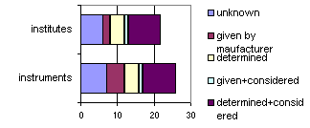
 | unknown |  |  |  | 7 |  |  |  | 6
 | given by manufacturer |  |  |  | 5 |  |  |  | 2
 | determined |  |  |  | 4 |  |  |  | 4
 | given+considered |  |  |  | 1 |  |  |  | 1
 | determined+considered |  |  |  | 9 |  |  |  | 9
 | 5 |  |  |  | 26 |  |  |  | 22

Stray light is
 |  |  |  |  | Instruments |  |  |  | Institutes |  |  | 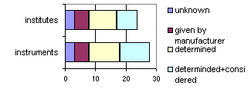
 | unknown |  |  |  | 3 |  |  |  | 3
 | given by manufacturer |  |  |  | 5 |  |  |  | 5
 | determined |  |  |  | 10 |  |  |  | 9
 | determined+considered |  |  |  | 10 |  |  |  | 7
 | 4 |  |  |  | 28 |  |  |  | 24

Measurement procedure

List of ancillary instruments at the measuring sites
 |  |  | Instruments |  | Institutes |  | 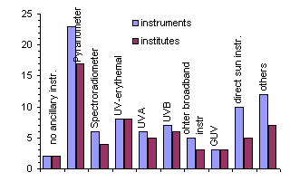
 | no ancillary instr. |  | 2 |  | 2
 | Pyranometer |  | 23 |  | 17
 | Spectroradiometer |  | 6 |  | 4
 | UV-erythemal |  | 8 |  | 8
 | UVA |  | 6 |  | 5
 | UVB |  | 7 |  | 6
 | other broadband instr |  | 5 |  | 3
 | GUV |  | 3 |  | 3
 | direct sun instr. |  | 10 |  | 5
 | others |  | 12 |  | 7
 | others: luxmeter, sky imager, sunshine recorder, LIDAR, Narrow-band radiometer, photodiode

Is somebody present during measurements?
 |  | Instruments |  | Institutes |  | 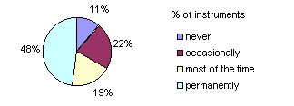
 | never | 3 |  | 3
 | occasionally | 6 |  | 6
 | most of the time | 5 |  | 5
 | permanently | 13 |  | 9
 | 4 | 27 |  | 23

Does uncertainty estimation for the spectral measurements exist?
 |  | Instruments |  | Institutes |  | 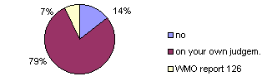
 | no | 4 |  | 3
 | on your own judgem. | 22 |  | 15
 | WMO report 126 | 2 |  | 2
 | 3 | 28 |  | 20

Are scans inspected for errors of the absolute level of measured irradiance?
 |  | Instruments |  | Institutes |  | 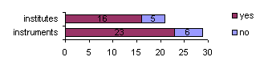
 | no | 6 |  | 5
 | yes | 23 |  | 16
 | 2 | 29 |  | 21

How is the absolute level checked?
 |  | Instruments |  | Institutes |  | 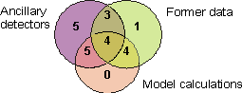
 | ancillary detectors | 17 |  | 12
 | model calculations | 13 |  | 10
 | former data | 12 |  | 11
 | 3 | 21 |  | 15

Are scans corrected depending on the absolute level of irradiance?
 |  | Instruments |  | Institutes |  | 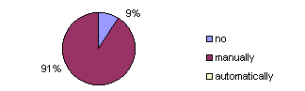
 | no | 2 |  | 2
 | manually | 20 |  | 14
 | automatically | 0 |  | 0
 | 3 | 22 |  | 16
Each group correcting the data makes a new calibration of the spectroradiometer.
Does everybody correct the old data afterwards?? Only one group reject "bad" scans.

Are scans inspected for wavelength shift?
 |  | Instruments |  | Institutes |  | 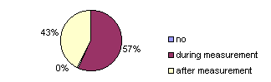
 | no | 0 |  | 0
 | during measurement | 17 |  | 13
 | after measurement | 13 |  | 11
 | 3 | 30 |  | 24

How is wavelength shift checked?
 |  | Instruments |  | Institutes |  | 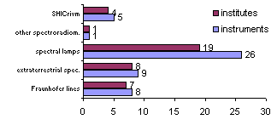
 | Fraunhofer lines | 8 |  | 7
 | extraterrestrial spec. | 9 |  | 8
 | former data | 0 |  | 0
 | spectral lamps | 26 |  | 19
 | other spectroradiom. | 1 |  | 1
 | SHICrivm | 5 |  | 4
 | 6 | 19 |  | 13
 | Two groups using SHICrivm also checked "extraterrestrial spectrum", the other 2 groups use SHICrivm to check the data afterward.

Are scans corrected depending on the wavelength setting?
 |  | Instruments |  | Institutes |  | 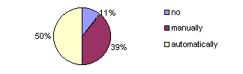
 | no | 3 |  | 3
 | manually | 11 |  | 8
 | automatically | 14 |  | 9
 | 3 | 28 |  | 20

What is corrected, if wavelength shift is detected?
 |  |  | Instruments |  | Institutes |  | 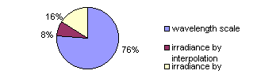
 | wavelength scale |  | 19 |  | 12
 | irradiance by interpolation |  | 2 |  | 2
 | irradiance by convolution |  | 4 |  | 3
 | 3 |  | 25 |  | 17

Are scans inspected for irregular values?
 |  | Instruments |  | Institutes |  | 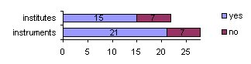
 | no | 7 |  | 7
 | yes | 21 |  | 15
 | 2 | 28 |  | 22

How are irregular values detected?
 |  | Instruments | Institutes | 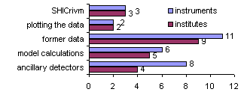
 | ancillary detectors | 8 | 4
 | model calculations | 6 | 5
 | former data | 11 | 9
 | plotting the data | 2 | 2
 | SHICrivm | 3 | 3
 | 5 | 30 | 23

Are scans corrected depending on irregular values?
 |  | Instruments | Institutes | 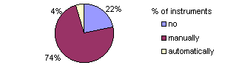
 | no | 5 | 5
 | manually | 17 | 12
 | automatically | 1 | 1
 | 3 | 23 | 18

How are irregular values corrected?
 |  | Instruments | Institutes | 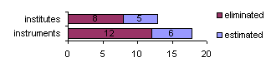
 | estimated values | 6 | 5
 | eliminated | 12 | 8
 | 2 | 18 | 13

Which parameters are considered for the cosine correction?
 |  | Instruments | Institutes | 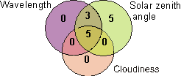
 | cloudiness | 5 | 4
 | wavelength | 8 | 6
 | solar zenith angle | 13 | 9
 | constant factor | 2 | 2
 | 4 | 15 | 11
 | 11 institutions are correcting the cosine error (15 spectroradiometers)

How is the time base controlled?
 |  | Instruments | Institutes | 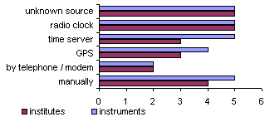
 | manually | 5 | 4
 | by telephone / modem | 2 | 2
 | GPS | 4 | 3
 | time server | 5 | 3
 | radio clock | 5 | 5
 | unknown source | 5 | 5
 | 6 | 26 | 22

Is the local horizon measured?
 |  | Instruments | Institutes | 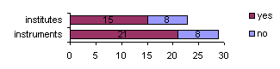
 | yes | 21 | 15
 | no | 8 | 8
 | 2 | 29 | 23

Is the albedo characterized?
 |  | Instruments |  | Institutes | 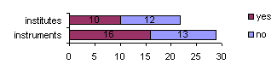
 | yes | 16 |  | 10
 | no | 13 |  | 12
 | 2 | 29 |  | 22

The albedo of the surrounding is
 |  |  | Instruments |  |  | Institutes
 | measured continuously |  | 2 |  |  | 1
 | estimated by model calculation |  | 2 |  |  | 1
 | recorded |  | 4 |  |  | 1
 | described |  | 7 |  |  | 6
 | 4 |  | 15 |  |  | 9

Is cloudiness recorded?
 |  | Instruments |  | Institutes | 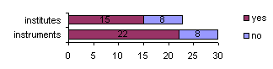
 | yes | 22 |  | 15
 | no | 8 |  | 8
 | 2 | 30 |  | 23

How often is cloudiness observed?
 |  | Instruments |  | Institutes | 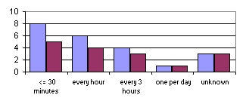
 | <= 30 minutes | 8 |  | 5
 | every hour | 6 |  | 4
 | every 3 hours | 4 |  | 3
 | one per day | 1 |  | 1
 | unknown | 3 |  | 3
 | 5 | 22 |  | 16

Methods, procedures and software for quality control of spectral UV measurements

These institutions gave information about control procedures
UJF, FMI, URO, ENEA, LAP, IFU, JRC, NTNU, UMIST, DWD, UI, SMHI,
STUK, INM, NRP, NILU

Information about uncertainty estimation of UV measurements
UMIST: Bartlett and Webb, JGR 105, 4889-4893
IFU: G.Bernhard, G.Seckmeyer: Uncertainty of measurements of spectral solar UV irradiance, JGR 104, 14321-14345, 1999

Absolute level of measured irradiance
Nobody has published a method to inspect the absolute level of irradiance yet!
Has somebody ??

URO: Comparison with ancillary detectors, model results and former data, correct spectrum manually
DWD: Compare three different spectroradiometers, recalibrate if necessary
LAP: Visual check, use former data and Pyranometer data, discard scan if it deviates more than 30% of "expected value"
NRP: Only when lamp scans measured outdoors indicate a change in spectral response > 1%
JRC: if there is a spike at only one measurement (wavelength) that is above a certain threshold (approx.50%).
UI: Visual check of ratio detector weighted (UV-Biometer) spectrum to detector signal (UV-Biometer)
UJF: the method we use will be described in Dominique Masserot's thesis, as soon as possible

NILU made the model calculations "FASTRT" available to the public at
"http://zardoz.nilu.no/~olaeng/fastrt/fastrt.html".
Mr. Engelsen wrote on Oct 3rd 2001: Just now the measured spectra in EDUCE flextor format are compared with simulated clear sky spectra. In the EDUCE project this tool will be improved to better separate instrumental errors from various atmospheric conditions. Click the text "Diagnosis of measured UV spectra".

Correction of the cosine error
DWD: Published at: Feister, U, R. Grewe, and K. Gericke: A method for correction of cosine
errors in measurements of spectral UV irradiance. Solar Energy 60 (1997) 313- 332.
Software available: In principle, we could provide it for free, but ...

FMI: 2 pages of description are available from Jussi Kaurola.
Software available: FMI is considering publishing their software under GNU General Public License (http://www.linux.org/info/gnu.html). In fact the method uses libRadtran software (http://www.uio.no/~arveky/libRadtran.html), which has already been published under GNU General Public License.

IFU: Published at: Seckmeyer and Bernhard, Cosine error correction of spectral UV irradiances, Atmospheric radiation, Proc. SPIE 2049, 140-151, 1993

LAP: Published at: Bais, A. F., S. Kazadzis, D. Balis, C. S. Zerefos, and M. Blumthaler, “Correcting global solar UV spectra recorded by a Brewer spectroradiometer for its angular response error”, Applied Optics, 37, 27, 6339 - 6344, 1998.
Software available: In principle yes (needs ancillary data (direct to global ratio) which are not standard to all instruments)

NRP: Cosine errors are negligible

UI: No cosine correction necessary because of "nearly ideal" diffuser

UJFJacqueline Lenoble: Eric Pachart thesis describes this correction. Available at the LOA, - USTL, bat P5, F59665 Villeneuve d'ascq, France.

UJF Thierry Cabot: with previous diffusers the method is described in "Measuring spectral diffuse solar irradiance with non-cosine flat-plate diffusers", Solar Energy, Vol.54, No.3, pp.173-182, 1995.
In the future, with new type of diffusers, no correction will be necessary.
Software available: "possibly" .

Wavelength shift
KNMI and SMHI: Brewer system software
Software available: "possibly"
NRP: published at Geophysical Research Letters, Vol. 22,no 20, pp 2721-2724. Applying the slit function measured in Nogic'96 with a HeCd-laser.
UI: Software available: "possibly", automatically calculate the wavelength shift after each scan (Fraunhofer lines); this shift is used for the wavelength setting of the following scan. Published by Huber, Blumthaler, Ambach (8) at SPIE 2049, p.354-357, 1993
UJF: correct all spectra automatically, a publication is submitted to Applied Optics in Jan.2001
Software available: "possibly"
RIVM: SHICrivm is free

Irregular values within a spectrum
BOKU: visually

DWD: compare three different spectroradiometers. If two spectra measured very close in time do not compare very well according to visual inspection the irregular one is removed. Spectra obviously distorted by clouds are not removed. Therefore, a cloud flagging algorithm is applied that is described in:
Feister, U. and K. Gericke: Cloud flagging of UV spectral irradiance, measurements. Atmospheric Research 49 (1998) 115 - 138
Software available: „possibly", The software for the cloud flagging method can be made available to other users (FORTRAN routine), though it would have to be adapted to different types of input formats.

FMI: compare with the normal shape of the spectrum

JRC: if there is a spike at only one measurement (wavelength) that is above a certain threshold (approx. 50%) the spectrum is corrected by using a reference spectrum measured with the same instrument that was checked manually to be without errors.

LAP: We have a software tool to check our spectra for spikes and irregular structure. The software does not correct automatically the spectra, but indicates graphically to the user the questionable wavelengths and suggests corrections. The user may accept or reject the corrections, or even discard the entire spectrum. The method is based on comparison of ratios between two subsequent wavelengths with those derived from a spectrum recorded on a clear day close to local noon. The suggested correction of the irradiance at a specific wavelength is based on the irradiance at the previous wavelength and the corresponding ratio of the reference spectrum.
A correction is suggested when the difference between the reference ratio and the actual ratio is larger than 0.5. A spectrum is eliminated (this is a user decision) when more than 10 spikes are detected or when the spectral structure seems to be unreasonable. The later occurs almost exclusively when the spectrometer is completely out of wavelength calibration (e.g. interruption of a spectrum without proper resetting of the gratings).
Software available: yes. It is already distributed to some Brewer users

UI: Visual check: ratio of all spectra to the maximal spectrum is plotted daily; spectra with spikes are eliminated manually.

UJF: signal is compared afterwards and compared with its range, method will be described in Dominique Masserot's thesis.

USTL: signal is compared afterwards and compared with its range

RIVM: SHICrivm

Information about SHICrivm
Usage:
11 groups have tried to use the software package
4 groups are using SHICrivm routinely
7 have never tried

Why is SHICrivm not used:
"lack of personal",
"only available as WINDOWS binary",
"unstable with Optronics data",
"only used for testing own software"

Problems with SHICrivm:
"a bit slow when checking a huge amount of spectra",
"input files are not created by the software itself",
"it takes a long time for determining the wavelength shift",
"the use for Single Brewers",

Suggestions:
"I prefer to have the option to specify the output files that are created. I have difficulty to implement it (in an automatic mode) to our system"
"There should be the possibility to check the spectrum for wavelength shifts without generating a convolved spectrum with a 1 nm slit"
"Make the source code available"

